**WEB BASED APPLICATION (DUAL LANGUAGE) ABOUT TRADITIONAL CHINESE MEDICINE INFORMATION**

**WITH TCM DIAGNOSE AND SYMPTOM CHECKER**

**DING YING KEEN**

**A project report submitted in partial fulfilment of the**

**requirements for the award of the degree of**

**Bachelor (Hons.) of Software Engineering**

**LKC Faculty of Engineering and Science**

**Universiti Tunku Abdul Rahman**

**April 2015**

DECLARATION

I hereby declare that this project report is based on my original work except for citations and quotations which have been duly acknowledged. I also declare that it has not been previously and concurrently submitted for any other degree or award at UTAR or other institutions.

|  |  |  |
| --- | --- | --- |
| Signature | : |  |
| Name | : | Ding Ying Keen |
| ID No. | : | 1102086 |
| Date | : |  |

APPROVAL FOR SUBMISSION

I certify that this project report entitled **“WEB BASED APPLICATION (DUAL LANGUAGE) ABOUT TRADITIONAL CHINESE MEDICINE INFORMATION WITH TCM DIAGNOSE AND SYMPTOM CHECKER”** was prepared by **Ding Ying Keen** has met the required standard for submission in partial fulfilment of the requirements for the award of Bachelor of Science (Hons.) Software Engineering at Universiti Tunku Abdul Rahman.

Approved by,

|  |  |  |
| --- | --- | --- |
| Signature | : |  |
| Supervisor | : | Ms. Chean Swee Ling |
| Date | : |  |

The copyright of this report belongs to the author under the terms of the copyright Act 1987 as qualified by Intellectual Property Policy of Universiti Tunku Abdul Rahman. Due acknowledgement shall always be made of the use of any material contained in, or derived from, this report.

© 2015, Ding Ying Keen. All right reserved.

Specially dedicated to

my beloved family

ACKNOWLEDGEMENTS

I would like to take this opportunity to thank everyone who had contributed to the successful completion of this project. I would like to express my deepest appreciation to my supervisor, Ms. Chean Swee Ling for her invaluable guidance and advice. Furthermore, his enormous patience throughout the development of this project.

In addition, I would also like to express my gratitude to my course mates and friends for their stimulating discussions when I’m facing problem during the development process.

Last and most importantly, I would like to thank my loving parent who had helped and given me support and encouragement during the preparation of this project.

**WEB BASED APPLICATION (DUAL LANGUAGE) ABOUT TRADITIONAL CHINESE MEDICINE INFORMATION**

**WITH TCM DIAGNOSE AND SYMPTOM CHECKER**

ABSTRACT

TABLE OF CONTENTS

DECLARATION ii

APPROVAL FOR SUBMISSION iii

ACKNOWLEDGEMENTS vi

ABSTRACT vii

TABLE OF CONTENTS viii

LIST OF TABLES xii

LIST OF FIGURES xiii

LIST OF SYMBOLS / ABBREVIATIONS xv

LIST OF APPENDICES xvi

**CHAPTER**

1 INTRODUCTION 1

1.1 Background 1

1.2 About Traditional Chinese Medicine (TCM) 1

1.3 Problem Statement 2

1.4 Client’s Background 2

1.5 Objectives 3

1.6 Scope 3

2 LITERATURE REVIEW 5

2.1 Personal website/profile 5

2.1.1 Dr. Rob Lamberts 5

2.1.2 Dr. Andrew Weil’s Daily Health Tips 6

2.2 Similar web sites with symptom checker/online diagnose 7

2.2.1 WebMD 7

2.2.2 Mayo Clinic 9

2.2.3 Doctor Spring 10

2.2.4 KingNet online hospital 11

2.2.5 Quan Tai Traditional Chinese Medicine (全泰中醫) 12

2.3 Teaching Hospital and Hospital in China 13

2.4 TCM diagnostic method and meaning in TCM of general symptoms 14

2.5 Map API 20

2.5.1 List of Map API 20

2.5.2 Comparison between Maps API 22

2.6 Hosting provider 23

2.6.1 List of hosting providers 23

2.6.2 Comparison of hosting provider 26

2.7 Server-side Scripting 27

2.7.1 PHP 27

2.7.2 ASP.NET 28

2.7.3 Python 29

3 METHODOLOGY 30

3.1 Software Development Methodology 30

3.2 Project Plan 31

3.2.1 Work Breakdown Structure 31

3.2.2 Gantt Chart 33

3.3 Development Tools and Language 34

3.4 Fact Finding 35

4 DESIGN 37

4.1 Introduction 37

4.2 Use Case 37

4.3 Activity Diagram 40

4.4 Database design 46

4.4.1 Entity Relationship Diagram 46

4.4.2 Data Dictionary 46

4.5 Storyboard design 51

5 IMPLEMENTATION 52

5.1 Introduction 52

5.2 Development tools and technology 52

5.2.1 Hyper Text Markup Language (HTML) 52

5.2.2 Cascading Style Sheets 54

5.2.3 Hypertext Preprocessor (PHP) 55

5.2.4 MySQLi 56

5.2.5 JavaScript 58

5.2.6 WampServer 59

5.2.7 ToolHeap: Test Mail Server Tool 59

5.3 Implementation flow 60

5.4 Code and justification 61

5.4.1 Commonly used variable and setting 61

5.4.2 Connect to database 61

5.4.3 Register 62

5.4.4 Log in 63

5.4.5 Display article (SELECT) 65

5.4.6 Post new article (INSERT) 65

5.4.7 Edit information (UPDATE) 66

5.5 Web hosting 67

5.5.1 Domain name 68

5.5.2 Upload and manage web page files 69

5.5.3 Database 72

5.5.4 Email account 73

TESTING 74

6.1 Introduction 74

6.2 Unit testing 74

6.2.1 Unit testing on register and log in 75

6.2.2 Unit testing on article 76

6.2.3 Unit testing on diagnose section 76

6.2.4 Unit testing on symptom checker 78

6.2.5 Unit testing of content in homepage and about Han Qi page 78

6.2.6 Unit testing on navigation link 79

6.3 Integration testing 80

6.4 Acceptance testing 89

7 CONCLUSION AND RECOMMENDATION 90

7.1 Contribution of project 90

7.2 Limitation of the system 90

7.3 Future enhancement 91

7.4 Conclusion 91

REFERENCES 93

APPENDICES 97

LIST OF TABLES

**TABLE TITLE PAGE**

**Table 2‑1 Daily Cost for Google Map API** (Google, 2014) 20

**Table 2‑2 Comparison between maps API** 21

**Table 2‑3 Comparison between Web Hosting Provider** 25

LIST OF FIGURES

**FIGURE TITLE PAGE**

**Figure 2.1 Dr. Rob Lamberts' Blog** 5

**Figure 2.2 Dr. Andrew Weil's Blog** 6

**Figure 2.3 WebMD Symptom Checker Interface** 7

**Figure 2.4 Mayo Clinic Symptom Checker Interface** 9

**Figure 2.5 DoctorSpring Questioning Section** 10

**Figure 2.6 KingNet Online Hospital** 11

**Figure 2.7 Quan Tai TCM Homepage** 12

**Figure 2.8 Symptom on Whole body and Overall Appearance** (Sacred Lotus Chinese Medicine, n.d.) 16

**Figure 2.9 Symptoms of Different Color on Face** (Sacred Lotus Chinese Medicine, n.d.) 17

**Figure 2.10 Symptoms on Eyes** (Sacred Lotus Chinese Medicine, n.d.) 17

**Figure 2.11 Symptoms on Nose** (Sacred Lotus Chinese Medicine, n.d.) 18

**Figure 2.12 Symptoms on Ears** (Sacred Lotus Chinese Medicine, n.d.) 18

**Figure 2.13 Symptoms on Gum** (Sacred Lotus Chinese Medicine, n.d.) 18

**Figure 2.14 Symptoms on Lips and Mouth** (Sacred Lotus Chinese Medicine, n.d.) 18

**Figure 2.15 Symptoms on Throat** (Sacred Lotus Chinese Medicine, n.d.) 19

**Figure 2.16 Screenshot of map from OpenStreetMap** (OpenStreetMap, 2014) 20

**Figure 2.17 Interface for configure map for Mapbox** (Mapbox, n.d.) 21

**Figure 3.1 Rapid Application Development Model** 29

**Figure 3.2 Gantt chart** 32

LIST OF SYMBOLS / ABBREVIATIONS

*TCM* Traditional Chinese Medicine

*IDE* Integrated Development Environment

*API* Application Program Interface

*RAD* Rapid Application Development

*ERD* Entity Relationship Diagram

*CSS* Cascading Style Sheets

*DBMS* Database Management System

*AJAX* Asynchronous JavaScript and XML

LIST OF APPENDICES

**APPENDIX TITLE PAGE**

APPENDIX A: Meeting Logs 40

APPENDIX B: Mock-up screen 46

## INTRODUCTION

### Background

This project aims to design and develop a web-based application with two languages (Chinese and English) for Traditional Chinese Physician to share Traditional Chinese Medicine (TCM) knowledge with the general public and provide symptom checker and TCM diagnosis. Most websites about TCM information and the online symptom checker and TCM diagnosis are belong to organizations instead of an individual.

### About Traditional Chinese Medicine (TCM)

Traditional Chinese Medicine is a broad range of medical practices, sharing general concepts which have been created in China and are based on a tradition of more than 2,000 years, including various forms of herbal medicine, massage, acupuncture, exercise and practice and eating regimen treatment. TCM practitioners use herbal medicines and different mind and body practices such as acupuncture and tai chi to treat or prevent health problems. (Dr. Jin, n.d.) (National Center For Complementary and Integrative Health, 2013)

### Problem Statement

In Malaysia, although more and more Malaysians started to know about TCM and use prescription of Traditional Chinese Medicine for various treatments, but some of them do not trust in TCM and they have some misunderstanding about TCM. They believe that knowledge and technique about TCM is passing from their parent or “Sifu” which mean teacher base on their own experience without any scientific proof and are not certified in an informal way. In fact, there are many universities or institution in worldwide, offering formaltrainingprograms in acupuncture and TCM practitioners.

### Client’s Background

Traditional Chinese Medicine practitioner, Chen Han Qi has 22 years of experience in Chinese Medicine, specializes in allergic rhinitis, insomnia, constipation, prostatitis, stomachache, diarrhea, facial paralysis, sinusitis, gynecology, infertility, menopausal syndrome, stoke sequelae, eye diseases, myopia, eyelid ptosis, etc.

She received a Master’s degree at Guangxi Traditional Chinese Medicinal University and she was Deputy Chief Physician and assistance professor of Jin Chuan Group Hospital (a third class B grade hospital in China which is also a teaching hospital). She is Malaysia qualified Registered Chinese Physician and currently working at Suntech Traditional Healthcare Sdn. Bhd. in Malaysia.

Because of the misunderstanding from people toward TCM, TCM practitioner, Chen Han Qi wants to share her knowledge and also her finding about TCM to the public through a personal web page. She wants to resolve the misunderstanding of people about TCM. The most important condition to let people to trust a TCM practitioner is his/her educational background. A qualified TCM practitioner is a well-trained and educated practitioner. Just like western medical, after graduate from medical school, TCM students obliged to prepare in a particular territory of solution before they go ahead to their own practices. They will be trained in teaching hospitals and are closely supervised by experienced TCM practitioners.

### Objectives

The intent of this project is to share the knowledge of Traditional Chinese Medicine (TCM) with the general public and provide symptom checker and TCM diagnosis. The objectives of this project are:

1. To share knowledge about Traditional Chinese Medicine and to increase the understanding of the people about TCM.

2. To allow people to have an online TCM diagnosis by submitting a photo of their tongue and describe their symptoms and symptom checker that provide the meaning of a specific symptom.

3. To allow patients to get the contact and information of the TCM practitioner, Chen Han Qi and know she will be at which clinic at certain day.

### Scope

1. **Posting article** which allows TCM practitioner, Chen Han Qi to post her finding or her knowledge about TCM so that anyone that visits the website can read about all the sharing.
2. **Search** function that allows visitors to search for an article that TCM practitioner post.
3. **Symptom checker** that allows visitor of the website to check for the meaning of a symptom.
4. **TCM diagnosis** allows visitors of the website to provide their symptom of sickness or illness with or without picture (max 1MB of image size) of their tongue to the TCM practitioner and then TCM practitioner will reply them with their problem.
5. **Map** that show the location of the clinic that Chen Han Qi will be at.
6. **Two types of language** will be use in the website which is English and Chinese.
7. **Information** of TCM practitioner, Chen Han Qi will be shown to the public including her educational background and contact info and it is editable by herself.
8. **Account registration** for user/patient to view their diagnose history.

Where there is enough time after completing the features mentioned above, the following features may be implemented:

* live chat with TCM practitioner

## LITERATURE REVIEW

### Personal website/profile

#### Dr. Rob Lamberts



**Figure 2.1 Dr. Rob Lamberts' Blog**

This is one of the personal blog that belong to Dr. Rob Lamberts. On this page, it only has the introduction of Dr. Rob Lamberts and the way to contact him. Then, he includes links to his social profile such as Facebook and twitter and also his other blog that he use to post articles about medicine, some about personal opinions and thoughts and a healthy dose of humour.

The first post on his blog is on March 2007 and continues until today. It also allows readers to share his post through a share button to readers’ Facebook, google+, twitter and etc.

Strength(s)

* Clean and tidy interface

Flaw(s)

* All the posts are arranged according to date, hence users are difficult to search for a certain area of topic

#### Dr. Andrew Weil’s Daily Health Tips

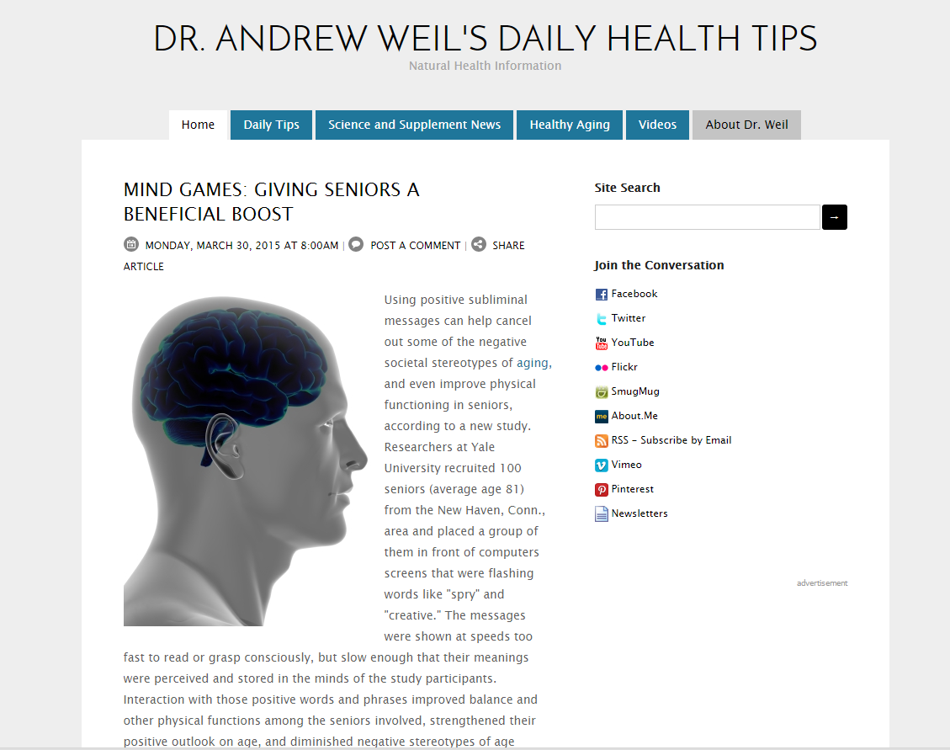

**Figure 2.2 Dr. Andrew Weil's Blog**

This blog belongs to Dr. Andrew Weil. The main focus for this blog is to share information about healthy lifestyle by sharing simple and actionable daily advice for readers to have an optimal health. Beside only sharing knowledge and information in words, he also includes video in a certain topic that he shares. On the website, Dr. Andrew also provides links to his social network profile. A lot of articles can be found on the website and from the archive of posting, we can see that he has started to post since November 2008 until now (March 2015) and still continues and there are about 7~38 posting every month.

Strength(s)

* Good effort by contributing useful knowledge and information to public.
* Clean interface
* Search on site function
* Clear self-introduction (Dr. Andrew Weil)

Flaw(s)

* Too many words in a page and the words are small and it might difficult for certain people to read it and eye will be tired if read for too long.

### Similar web sites with symptom checker/online diagnose

#### WebMD

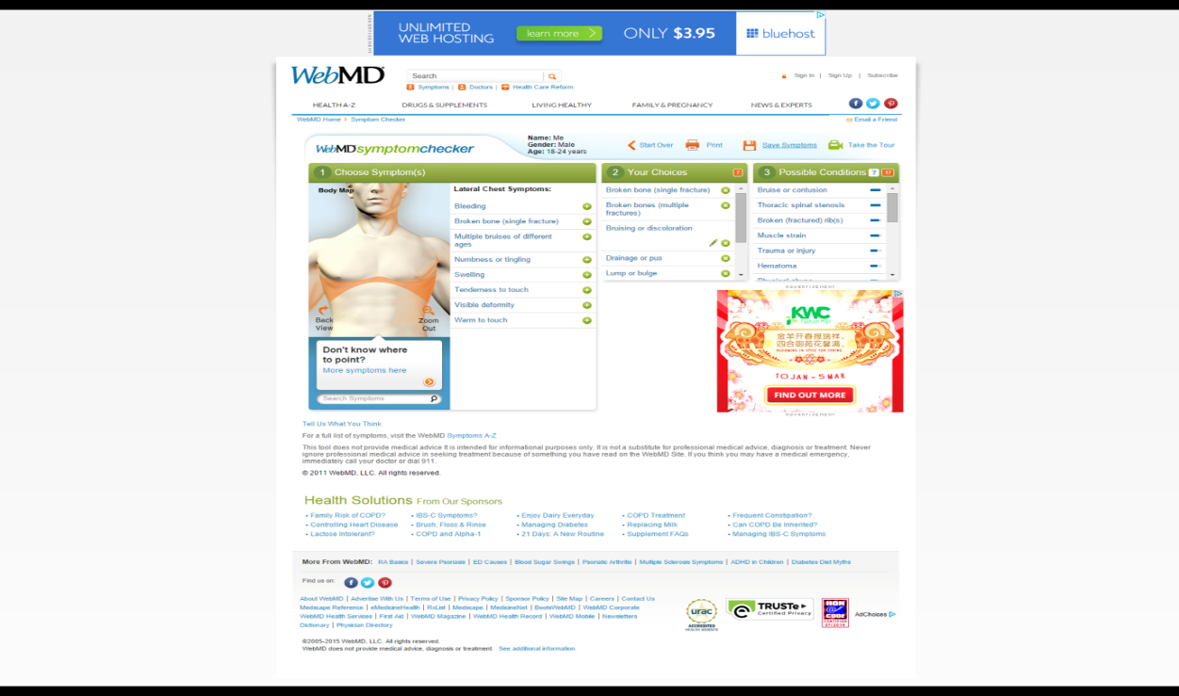

**Figure 2.3 WebMD Symptom Checker Interface**

WebMD is based in New York with principal offices in New York and Atlanta, Georgia. It was established in 1996 by Jim Clark and Pavan Nigam and WebMD is financed by promoting, outsider commitments and sponsorships (Writers Write. Inc, 2005). The domain name for this website was registered on 1998-04-06. It is a western medical website that gives significant health information, tools for managing health and support to those who seek information. However, the contents of the WebMD Site such as graphics, text, pictures and other material on the WebMD Site are for informational purposes only. All the contents are not proposed to be a substitute for consulting professional medical advice, diagnosis or treatment.

With the WebMD symptom checker, it requires users to provide gender and age group before users are allowed to choose the symptoms by clicking the body part of a human body image then select the symptom from the list that provided. After choosing all the symptoms, the result will show the overview of the symptoms that selected, what to expect, made worse by, treatment, self-care, when to see a doctor, how common is the symptoms and risk factors. It also allows patients to ask doctor question about the symptoms.

Strength(s)

* Contain health and drugs & medication information
* A search function that allows user to search content and information from this web site
* Provide physicians directory, hospital directories and pharmacy directory in United State.
* Provide latest health care news

Flaw(s)

* The space provided for a list of symptoms is not enough and causes the words overlapping one over another and do not display fully.

#### Mayo Clinic

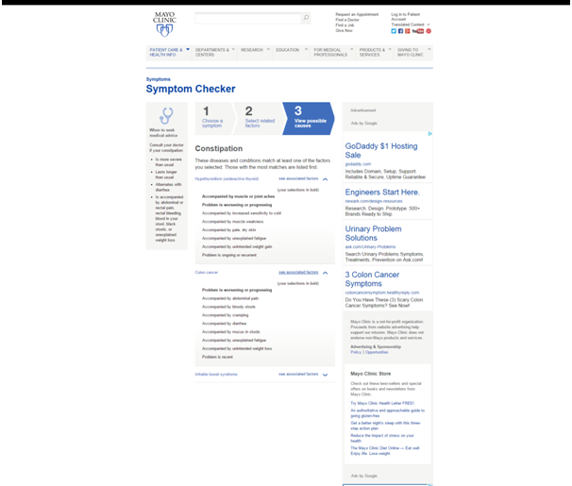

**Figure 2.4 Mayo Clinic Symptom Checker Interface**

Mayo Clinic is a non-profit medical practice and medical research group established in Rochester, Minnesota (Mayo Clinic, 2014). The domain name for this website was registered on 1997-08-02. It is a western medical website that has a much clean and simple interface. It provides patient care and health info and also research about the medical field.

The symptom checker for this website is much simpler. Users can find a symptom by its first letter or choose the symptom from either adult or children's category. If choosing a symptom by its first letter, then it will only provide the information about the selected symptom. In the other hand, if choosing symptom checker under adult or children's category, it will allow users to choose the descriptions for the symptom such as where the pain located, triggered or worsened by, accompany by and etc. After selecting all the required answers, it will list out all the possible causes based on the selected symptom descriptions.

Strength(s)

* Request appointment at Mayo Clinic in US.
* Doctors and medical staff directories that work at Mayo Clinic in US.

Flaw(s)

* It only allows patients to choose the symptoms and descriptions from a list.

#### Doctor Spring

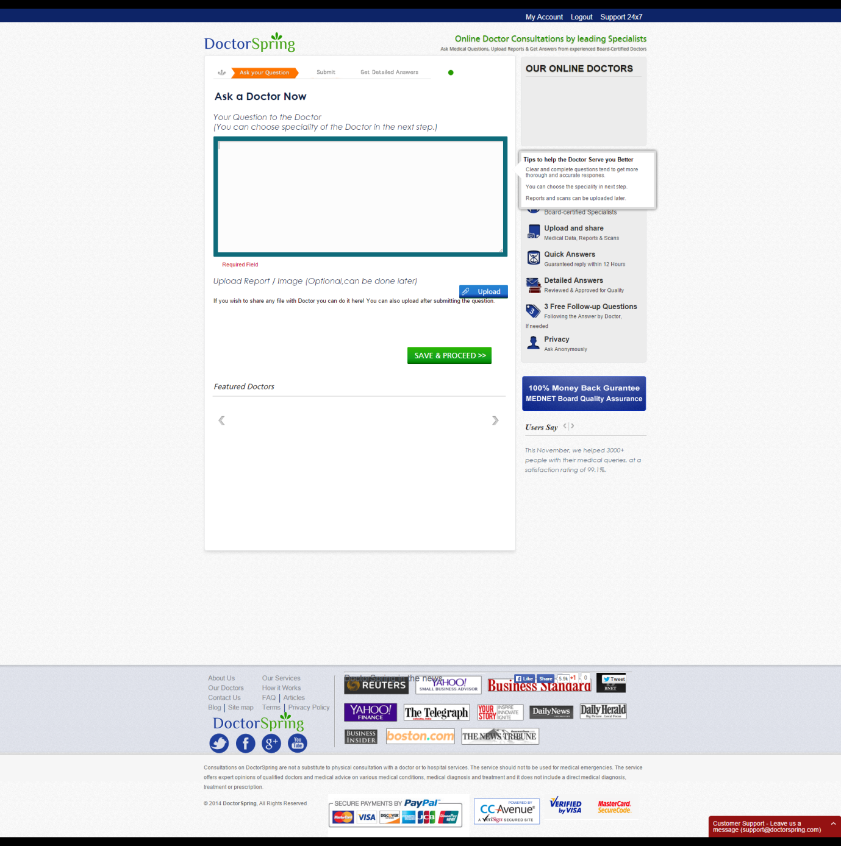

**Figure 2.5 DoctorSpring Questioning Section**

The domain name for this website: [www.doctorspring.com](http://www.doctorspring.com) is registered on 2011-08-14.

This website is more like an online consultation with doctor and users must pay to get the service. It targets those people that seeking medical consultation online from qualified doctors and does not include a direct medical diagnosis, treatment or prescription. It does not mean to substitute to have a physical consultation with a doctor or to hospital services. Users can either choose to ask a doctor or consult a specialist in MD or get a medical board opinion. Each of these is with different price. Users just need to provide the description or question and upload a report/image (optional) using the form provided on the web site.

Strength(s)

* Has 146 doctors in 41 specialist
* 8.5 hours of average time to answer

Flaw(s)

* Need to pay for the consultation
* Do not content any medical or health information. More like an online medical consultation business website.

#### KingNet online hospital

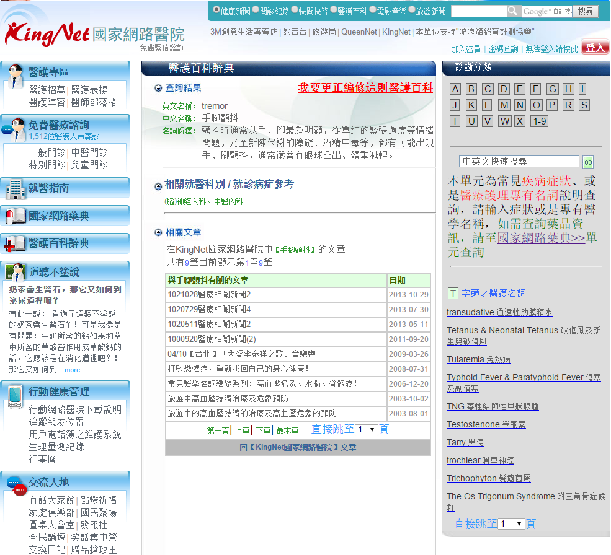

**Figure 2.6 KingNet Online Hospital**

The KingNet National Online Hospital was established by the founder of KingNet International Corporation in 1996. The domain name for this website <http://kingnet.com.tw> was first registered on 1997-05-01.

The KingNet National Online Hospital provides many healthcare information such as medicine dictionary, medical dictionary and some application. This symptom checker for this website is mostly like a dictionary style searching. Users can either choose from a list or type in manually to search for the details of certain symptom but it only explains for the symptom. If the users need to know more details, such as how to cure it, they must log in as a member in order to ask question to doctor and then the doctor will reply.

Strength(s)

* Heal and medical information that belongs in the same category or categories together for easy browsing
* Have both English and Chinese version for the medical term

Flaw(s)

* Webpage is too crowded with words hence a bit not user friendly.

#### Quan Tai Traditional Chinese Medicine (全泰中醫)

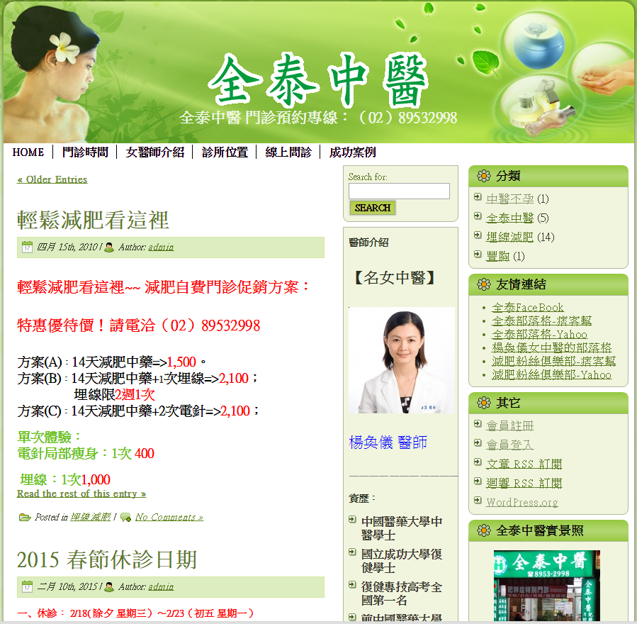

**Figure 2.7 Quan Tai TCM Homepage**

A Taiwan based TCM website that provides news about the clinic, health information, TCM practitioner information and etc. However, this website seems like more focus on providing information about a healthy diet for a healthy lifestyle and body slimming. For online diagnose, users just need to post a comment at the “online asking” section about their problem, then the doctor will reply it on the website. If users want to have a private reply, they need to sign in as a member so the doctor will reply as a private message.

Strength(s)

* Simple and easy to understand interface.
* Search function for the forum of the website.

Flaws(s)

* Simple and easy to understand interface.

### Teaching Hospital and Hospital in China

Teaching hospital is a hospital that is associated with a medical school and provides the means for medical education to students, interns, residents and sometimes postgraduates. Some teaching hospitals have other students too such as nursing students. Any students who are in training in hospitals are firmly administered by others with more experience. (Steven Dowshen, 2013)

In China, most hospitals are controlled by government while there are also private clinics in China and many of the private practitioners practice traditional Chinese medicine (TCM) rather than western medical. Hospitals in China are separated into three-level framework: primary, secondary and tertiary institutions which recognize a hospital’s ability to give medical care, medical education and conduct medical research.

Primary hospitals are basically township hospitals that provide preventive care, minimal health care and rehabilitation services and must contain a total number of 20 to 99 of beds. (Chinadmd, n.d.)

Secondary hospitals tend to be affiliated with a medium size city, county or district and in charge of giving comprehensive health services in addition to medical education and conducting research on a regional basis. Secondary hospitals must contain more than 100 beds but less than 499. (Chinadmd, n.d.)

Tertiary hospitals provide different specialist health services to the public at the city, provincial and also national level. They are comprehended with all the facilities and technologies that are necessary to diagnose and treat the needy. With a bed capacity exceeding 500, tertiary hospitals sure can accommodate those who are in need for further management and requiring admission. It not only serves to treat the needs, tertiary hospital is also used as a teaching hospital for the medical schools all over the region and it also serves as a scientific research centre. (Chinadmd, n.d.)

These three grades are further subdivided into three subsidiary levels: A, B and C based on the level of service provision, size, medical technology, medical equipment, and management and medical quality. In addition, one special level - 3AAA is reserved for the most specialized hospitals.

### TCM diagnostic method and meaning in TCM of general symptoms

A TCM doctor makes a diagnosis based on the clinical information that he or she gather then analyses and interprets the data. The Chinese believe that the human body is a natural entire and all parts are associated with one another by channels and collaterals or also known as meridians (Raka Dewan, Integrated Chinese Medicine Holdings Ltd., n.d.). For example, tongue. The tongue plays an important and useful role during inspection of TCM diagnosis because tongue has many relationships and connections in the body both to the meridians and the internal organs such as heart, kidney, bladder and other. (Sacred Lotus Chinese Medicine, n.d.). This explains why the project’s client, Chen Han Qi wants patients to include the image of their tongue for online diagnose according to their will. There are four examination methods which are listening, questioning, inspection and smelling and palpation.

In this project, information for TCM practitioner to collect from patients can only through questioning and inspection (a photo of patients’ tongue). Commonly, a TCM practitioner will make inquiries about the following symptoms:

* Chills and fever

A person's reaction to cold and heat can help to recognize between internal or external damage causes of illness. If patients feel chills or fever, ask for how long have it been and other symptom along with it. (Raka Dewan, Integrated Chinese Medicine Holdings Ltd., n.d.)

* Perspiration

Question about when, where and how much the patient sweats will be asked if a patient sweat. The evils or vital energy (qi) is abundant or weak and whether the sweat pores are opened or blocked can be known from the patterns of perspiration. (Raka Dewan, Integrated Chinese Medicine Holdings Ltd., n.d.)

* Appetite, thirst and taste in mouth

The body's organs rely on food and water for nourishment, which are sourced from the spleen and stomach to make nutrient essence. Questions about thirst, appetite and taste uncover the status of the working of spleen and stomach. (Raka Dewan, Integrated Chinese Medicine Holdings Ltd., n.d.)

* Defecation and urination

The spleen and stomach govern the reception of water and food and perform digestion and transformation functions to transform them into nutrient essence used by the body. The kidneys, large intestine, triple burner and urinary bladder are all included in the urination and defecation processes and interact with the spleen and stomach. Hence, by inquiring about stools and urine, the practitioner can get some answers concerning the working of every one of these organs. (Raka Dewan, Integrated Chinese Medicine Holdings Ltd., n.d.)

* Pain

Pain is a standout amongst the most widely recognized complaints of patients. TCM practitioner will concentrate on asking the nature and locations of pain. The way of the pain serves to recognize its etiology (cause) and pathology, while are of the pain helps to figure out which organs and meridians may be influenced. (Raka Dewan, Integrated Chinese Medicine Holdings Ltd., n.d.)

* Sleep

By getting some information about sleep patterns, TCM practitioner can accumulate information about whether the symptoms are of an excess (shi) or deficiency (xu) type syndrome. (Raka Dewan, Integrated Chinese Medicine Holdings Ltd., n.d.)

* Sex and reproductive system

Basis of female physiology is firmly identified with illnesses so a TCM practitioner will get some information about their menstrual cycle, vaginal discharge, pregnancy and childbirth history. (Raka Dewan, Integrated Chinese Medicine Holdings Ltd., n.d.)

In order for TCM practitioner to have all the required information, patients will be required to answer those questions that provided in online diagnose section with some other description on their own and the medical advice can only give by the TCM practitioner.

Figures below show the general symptoms and the meaning in TCM.

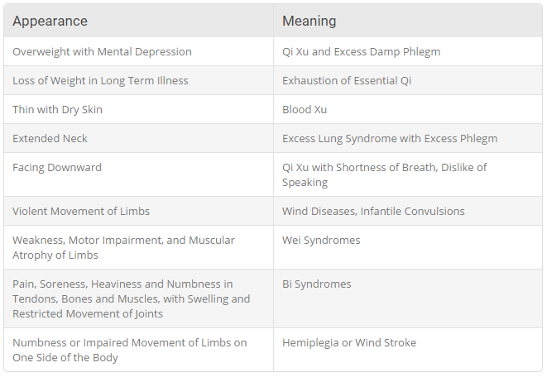

**Figure 2.8 Symptom on Whole body and Overall Appearance** (Sacred Lotus Chinese Medicine, n.d.)

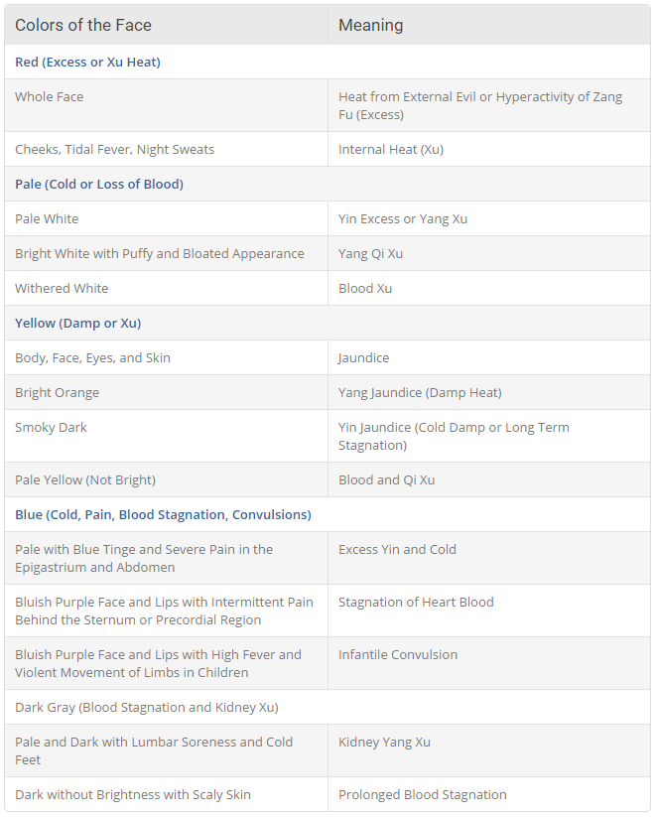

**Figure 2.9 Symptoms of Different Color on Face** (Sacred Lotus Chinese Medicine, n.d.)

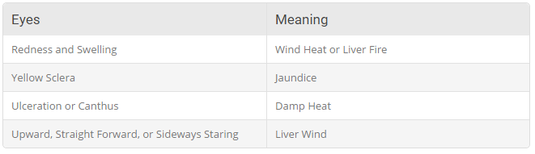

**Figure 2.10 Symptoms on Eyes** (Sacred Lotus Chinese Medicine, n.d.)

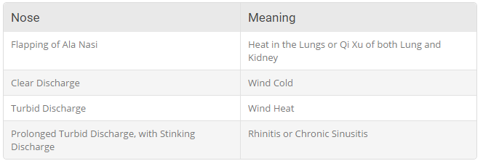

**Figure 2.11 Symptoms on Nose** (Sacred Lotus Chinese Medicine, n.d.)

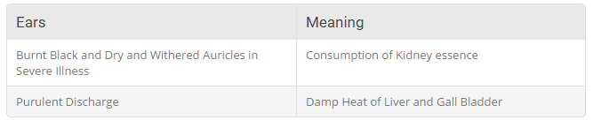

**Figure 2.12 Symptoms on Ears** (Sacred Lotus Chinese Medicine, n.d.)

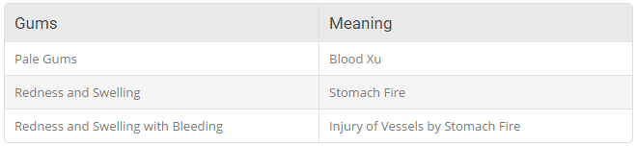

**Figure 2.13 Symptoms on Gum** (Sacred Lotus Chinese Medicine, n.d.)

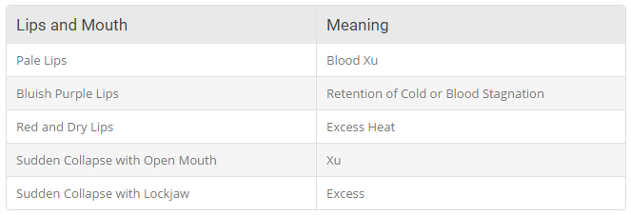

**Figure 2.14 Symptoms on Lips and Mouth** (Sacred Lotus Chinese Medicine, n.d.)

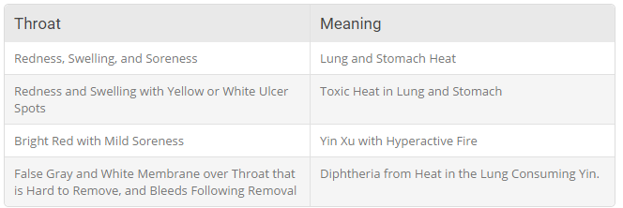

**Figure 2.15 Symptoms on Throat** (Sacred Lotus Chinese Medicine, n.d.)

### Map API

Getting map location is important for someone to know where a place is. People may not have any idea where a place is through address written in words. In order to allow patients to meet TCM practitioner face-to-face, it will be much easier if provided them with a map that specify where the place is. To do this, the most ideal situation is to utilize a map API that supplies all the data required and to let people look around the map to know the surrounding of a location.

#### List of Map API

##### Google Map and Google Place API

Google offer Place API for free, Google Place API allows developers to retrieve fundamental data of the organizations that is accessible on the Google Map. Google Map API allows client to utilize the component that is accessible in Google Map and allow customization. Both Map and Place API can be created using JavaScript yet Google Map API is not free, if the request is over 25000 for every day Google will begin to charge the use expenses. (Google, 2014)

**Table 2‑1 Daily Cost for Google Map API** (Google, 2014)

|  |  |
| --- | --- |
| Daily Map Loads | Cost per day (USD) |
| 5,000 | 0 |
| 15,000 | 0 |
| 25,000 | 0 |
| 35,000 | 5 |
| 45,000 | 10 |
| 75,000 | 25 |
| 100,000 | 37.50 |

##### Open Street Map

OpenStreetMap is free to use for any reason as long as user credit OpenStreetMap and its contributors. It is built by a group of mappers that contribute and maintain information about streets, trails, bistros, railroad stations and much more all over the world. OpenStreetMap support numerous development method included JavaScript.

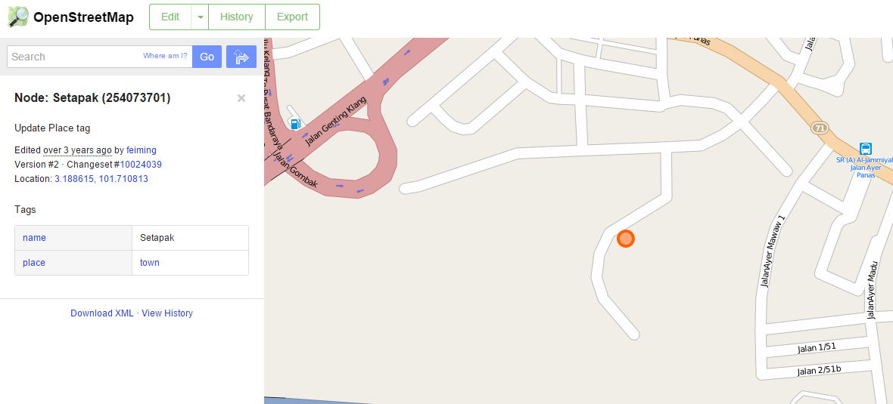

**Figure 2.16 Screenshot of map from OpenStreetMap** (OpenStreetMap, 2014)

##### Mapbox

Mapbox is an open source organization that constructs their product with open source parts, work in the open and release as much code as possible (Mapbox, n.d.). Mapbox make use of other open source map API and act as a middle man for the Map provider and developer. Mapbox added adaptable code to other open source Map Application to improve a better map appearance and allow developers to modify using the API provided and distribute to the mobile apps or website easily.

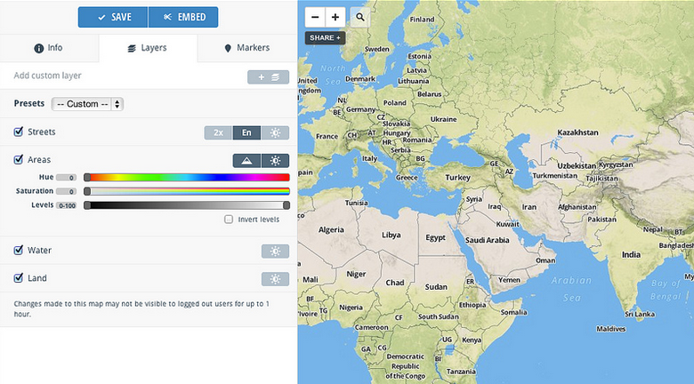

**Figure 2.17 Interface for configure map for Mapbox** (Mapbox, n.d.)

#### Comparison between Maps API

**Table 2‑2 Comparison between maps API**

|  |  |  |  |
| --- | --- | --- | --- |
|  | **Google Map/Place API** | **OepnStreetMap API** | **Mapbox API** |
| **Performance** | Fast | Moderate | Slower than original map provider |
| **Appearance** | Good | Average | Very good |
| **Price** | Free for the initial 25000 load within 90 days | Free | Free for first 3000 loads per month |
| **Complexity** | Easy | Very complex | Average |

### Hosting provider

The client of this project, TCM practitioner Chen Han Qi wants to host this website online, so choosing a web hosting provider must be a concern and because of Chen Han Qin do not have much time to spend to manage the website so she prefer to choose a free hosting server to run the website first. There is also some hosting provider that offers to upgrade to a premium account which will charge a month or annually with a much better features.

#### List of hosting providers

##### ServersFree

ServersFree is a free web server provider. It provides web hosting service to people around the world without any hidden cost and advertisement even support for the server hosting is free. It also provides free server tools that are reliable and easy to use. (Serversfree, n.d.)

Features

* No advertisements
* 100gb of bandwidth
* 10gb of disk space
* 5 FTP account
* Unlimited add-on domain
* 5 email accounts
* 5 MySQL databases
* 5 free sub domains
* 5 parked domain
* Free Subdomains (*.bugs3.com etc.)

Performance

All of the free servers are based on Dual Quad processor, Multiple 10 gigabit Ethernet connections and custom compiled Linux operating system kernel with Apache servers for more advanced and fast performance for all our users. (Serversfree, n.d.)

Reliability

ServersFree provides strict protection for users’ data and secure it against most malicious actions. All free hosted data are backup automatically and with the easy server tools, it provides users to back up their website or personal data with a few clicks. (Serversfree, n.d.)

##### 000Webhost

000Webhost provides both free and premium hosting ($4.84 per month). For the free hosting service, it has no hidden costs, no restrictive term and no advertisements. 000Webhost also guarantee that they managed to reach 99.9% uptime for most of the servers.  (000Webhost, n.d.)

Features (free hosting)

* Free
* 1500mb disk space
* 100gb/month data transfer
* 5 add-on domains
* 5 sub-domain
* 5 email addresses
* 2 MySQL databases
* 1 FTP account
* Free subdomain (*.comli.com)

Features (premium hosting)

* Unlimited email address
* Unlimited data transfer
* Unlimited add-on domain
* Unlimited sub-domain
* Unlimited disc space
* Unlimited MySql database
* Unlimited FTP account
* Free domain name of user’s choice
* And some other advance features

##### 5GBfree

5GBfree is an online free website hosting organization that helps people to host beginner sites for free. 5GBfree is U.S. based, PCI and SAS 70 Type II certified data centre which mean 5GBfree is a secure hosting company. 5GBfree will also not sell any of users’ information and also advertisements on users’ site that host on 5GBfree. Support for free accounts is provided exclusively through a forum or users can choose to upgrade their account into 5GB Pro which cost $2.95 monthly that provides access to live US-based support. (5GBfree, n.d.)

Features (5GBfree)

* Free of charge
* 5gb space
* 1 FTP account
* 20gb bandwidth
* 3 MySQL Databases
* 1 add-on domain
* 1 parked domain
* Free domain name

Features (5GB Pro)

* Unlimited space
* Unlimited FTP account
* Unlimited bandwidth
* Unlimited add-on domain
* Unlimited MySql databases
* Unlimited parked domain
* Free domain name

#### Comparison of hosting provider

**Table 2‑3 Comparison between Web Hosting Provider**

|  |  |  |  |  |  |
| --- | --- | --- | --- | --- | --- |
|  | ServersFree | 000Webhost | 000Webhost (Premium) | 5FBfree | 5GB Pro |
| **Website Space** | 10GB | 1500MB | Unlimited | 5GB | Unlimited |
| **Bandwidth** | 100GB | 100GB | Unlimited | 20GB | Unlimited |
| **Parked Domain** | 5 | - | unlimited | 1 | Unlimited |
| **Add-on domain** | unlimited | 5 | Unlimited | 1 | Unlimited |
| **Sub Domain** | 5 | 5 | Unlimited | 25 | unlimited |
| **FTP account** | 5 | 1 | Unlimited | 1 | Unlimited |
| **MySQL database** | 5 | 2 | Unlimited | 3 | Unlimited |
| **Email Account** | 5 | 5 | Unlimited | No | unlimited |
| **Advertisement** | No | No | No | No | No |
| **Extra** | Free Subdomains (*.bugs3.com etc.) | Free subdomain(*.comli.com) | Free domain name of user’s choice | Free domain name | Free domain name of user’s choice |
| **PRICE** | Free | Free | $4.84 monthly | Free | $2.95 monthly |

### Server-side Scripting

Server-side scripting is a script or language that uses in web development that involves in web server or database. A user’s request to the server will be done by running a script directly to the web server. (Scottish Qualifications Authority, 2010)

#### PHP

PHP is a server-side scripting which the code is executed on the server, generating HTML which is then sent to the client. (php, n.d.) The client would receive the results of running that script however would not know what the underlying code was. PHP offers higher adaptability compare to other server-side scripting. It can be written in any text editor but other language like ASP.NET, it has to utilize Microsoft Visual Studio to create the code. PHP is also not OS specific as it can run on several operating systems like Windows, UNIX and LINUX OS. In addition, the support and documentation for PHP is much easier as the support forums which aid the language is completely free. Support through the community of the language will be easy too as the community is huge. (EffOne Technologies, 2014). PHP extension also available to allow PHP scripts to connect to various Database Management System such as SQLite, MySQL, Oracle, etc. (Yank, 2001)

Advantages of PHP

* Free
* Easy to learn
* Has broad API documentation and built-in functionality for many common tasks.
* Can run on many platforms
* Stable as it is maintained by many developers

Disadvantages of PHP

* Security concern because it is open source, people can explore weaknesses and use bugs that found
* Not suitable for very large project because it is hard to maintain

#### ASP.NET

ASP.NET is an open source server-side web application framework intended for Web developers to create dynamic web pages. It was produced by Microsoft to allow programmers to build dynamic websites, web applications and web services. ASP.NET is not restricted to script languages, it allows to make use of .NET languages like C#, J#, VB, etc. It allows developers to build very compelling applications by making use of Visual Studio, the development tool provided by Microsoft. ASP.NET is purely server-side technology. (Kozyk, n.d.)

Advantages of ASP.NET

* ASP.NET provides drag and drop function
* If the process is dead a new process can be created in its place because the processes are closely monitored and managed by the ASP.NET runtime
* ASP.NET decrease the amount of code needed to build a large application

Disadvantages of ASP.NET (Anand, 2011)

* Limited control over HTML
* Complicated life-cycle
* Limited support for testing
* Not flexible as it needs to utilize Microsoft Visual Studio to create the code

#### Python

Python is an object-oriented, high level and interpreted programming language for the web. It is also regarded as a strong server side scripting language. Python code resembles the pseudo code just like all the scripting languages. The elegant design and syntax rules of this programming language make it quite readable even among the multi programmer development teams. (Smith, 2013)

Advantages of python

* The syntax of Python is easy to read and clear.
* Easy to learn
* Offers quick feedback in a lot of ways
* Able to run on multiple systems and has a similar interface on different platforms

Disadvantages of Python

* Python is much slower than some other languages
* Lack of compile-time type checking
* Significant whitespace issue because Python use space to denote as a block instead of using curly brackets like other languages

## METHODOLOGY

### Software Development Methodology

The software development methodology is chosen for this project is Rapid Application Development (RAD). RAD is intended to give much faster development and higher quality software compares to others traditional lifecycle and less emphasize on planning tasks. (McQuaid, n.d.) Rapid Application Development approach allows flexibility in adjusting the requirement as the project progresses when necessary. As a result, modularizing the software is essential to be evaluated and refined as the project progresses. In addition, this approach is more appropriate for software development that emphasize on user interface. Hence, it encourages the use of Computer Assisted Software Engineering (CASE) tools for development of the graphic user interface application to speed up the designing and development process. In this project, the functions of the application will be divided into smaller module. Each of the modules will be developed and tested before the next module starts which fulfilled the RAD.

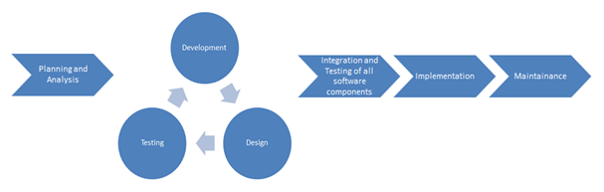

**Figure 3.1 Rapid Application Development Model**

There are 4 phases in RAD,

1. Requirement & Planning Phase

* Requirements Elicitation and Analysis.

2. User Design Phase

* Design the models of the system. Include user interface and system functionalities. Build a prototype for testing.

3. Construction Phase

* Coding & Debugging takes place

4. Cutover Phase

* Final testing before deliver to customer/user. The user/client will train to use the system.

RAD is suitable for:

* Project requirements and scope can be clearly defined
* Developers are skilled.
* Low risk program
* Tight deadline
* Project scale is small

### Project Plan

#### Work Breakdown Structure

This project will be divided into 6 phases which are:

1. Planning and Analysis
2. Designing
3. Development
4. Testing
5. Deployment
6. Documentation

The details of work breakdown structure are as follows:

1. Planning and Analysis
   1. Research on Confirmed Topic
   2. Problem Statement, Objectives and Scope Formulation
   3. Requirement Elicitation and Analysis
   4. Preliminary Report Writing
   5. Preliminary Report Submission
   6. Literature Review
      1. Teaching hospital and hospital in China
      2. Similar website with symptom checker/online diagnose
      3. Personal website/profile
      4. Map API
      5. Web hosting provider
      6. Server-side scripting
   7. Development Methodology
   8. Development Tools Research
   9. Project Plan
   10. Proposal Writing
   11. Proposal Submission
   12. Proposal Presentation Slides Preparation
   13. Proposal Presentation
2. Design
   1. Architecture Design
   2. Functional Design
   3. User Interface Design
   4. Design Review
   5. Design Refinement
3. Development
   1. Coding and Debugging
4. Testing
   1. Unit Testing
   2. System Testing
   3. System Integration Testing
   4. User Acceptance Testing
5. Deployment
   1. Application Environment Setup
   2. Presentation Preparation
   3. Demonstration and Presentation
6. Documentation
   1. Thesis Writing
   2. Thesis Review
   3. Thesis Refinement
   4. Thesis Submission

#### Gantt Chart

The figure below show the Gantt chart of the work breakdown structure.

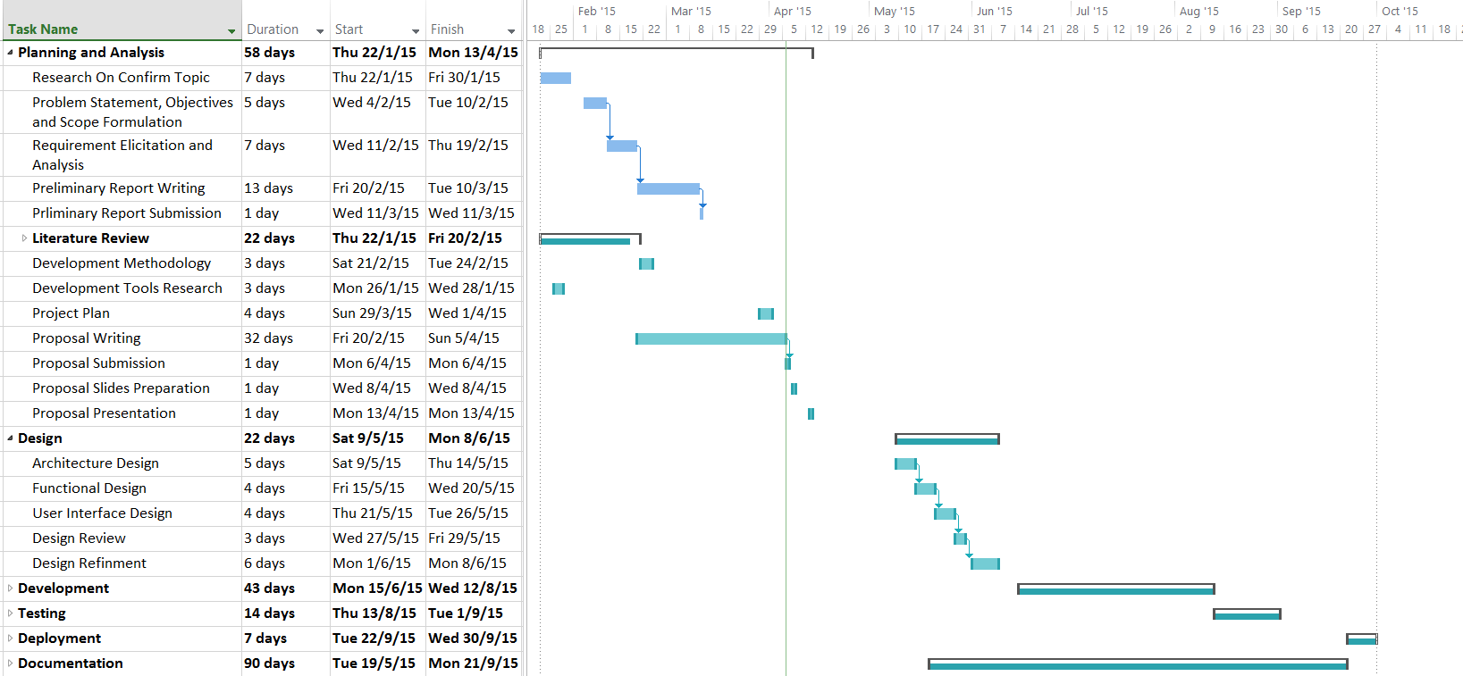

**Figure 3.2 Gantt chart**

### Development Tools and Language

* **Notepad++**

Notepad++ will be used to develop the website instead of using an IDE such as Microsoft Visual Studio is because need to pay for some extension for developing a web application such as extension for PHP. Notepad++ is a free source code editor and Notepad replacement that supports several languages and the main point is it has a clean interface.

* **WampServer**

WampServer will be used as a web development environment which will serve as a local host. It allows creating web applications with PHP and a MySQL database and we can use phpMyAdmin to manage database easily.

* **JavaScript**

JavaScript will be the programming language that uses to make web pages interactive. It is embedded in HTML pages and runs on the visitor's computer which doesn't require constant downloads from websites. It is client-side scripting and designed for performing dynamic tasks with high interactivity options. JavaScript is also platform independent. It can be run on any browser that is JavaScript enabled. (Chapman, n.d.) (WEBLINKINDIA. , 2012)

* **HTML and CSS**

HTML and CSS will be used as a development language as they are the two of the core technologies for building web pages. HTML provides the structure of the page and is a markup language for describing web documents (w3schools, n.d.). CSS is the language for describing the presentation of Web pages, including layout, colours and fonts. It allows to adapt the presentation to different types of devices, such as large screens, small screens, or printers. (W3C, 2014)

* **MySQLi**

MySQLi which is one of the most widely used DBMS for web application and it is an improved version of MySQL will be used. It is an extension for PHP, often referred to as MySQL improved. Some features of MySQLi are:

* Object oriented interface, making it easier to use
* Support for prepared statements, helping secure the code
* Support for multiple statements, allowing to run more than one query at a time

MySQLi not only has an object oriented interface but also a procedural one which make it even more widely usable. (Mike, 2011)

* **Apache Web Server**

Apache is generally recognized as the world’s most popular web server. It was originally designed for Unix environments then the Apache Web server has been ported to Windows and other network operating systems. It provides many web features such as SSL, CGI and virtual domains. (Mitchell, n.d.)

### Fact Finding

The author did an interview with the project’s client, Traditional Chinese Medicine practitioner Chen Han Qi at Suntech Traditional Healthcare Sdn. Bhd which is located at Puchong. The author asked about the purpose and objective for her to design a webpage. According to the interview, Chen Han Qi feels that people have a lot misunderstanding toward TCM so she wants to resolve this misunderstanding by sharing her finding and knowledge about TCM. In order for the public to believe TCM or a TCM practitioner, the background of the TCM practitioner is important so she explains a lot about hospital at China and where she graduate from. She wants to let the public know that a qualified TCM practitioner actually experience and graduate like how other practitioner does and not just passing of knowledge from parents so the background information such as where she graduate from, what is her previous experience and job position is important to show on the website.

Beside for the website to allow her to post something, she also wants an online diagnose system which allows patients to provide their symptoms of sickness with or without an image of their tongue and then she can replay them, but currently she did not have any idea on how she wants this specific function to be so she will email the author once she has any idea about this but for sure is it must have some guide for patients so that patients will provide a specific and required detail.

As she said that she do not have much time to spend on managing this website, so she decides to take a free hosting server first even the domain name of free hosting server will have same name on it for example: [www. (name).bugs3.com](http://www.(name).bugs3.com). Due to the time constraint, the interview has to end and further discussion will be discussed through email.

## DESIGN

### Introduction

In the design phase, a systematic process of designing the front-end and the back-end of the system are determined and planned. During this stage, the storyboards, user interface and the databases are designed. Besides that, the architecture design and system flow chart are also illustrated. Below are the components that will be considered during this phase:

* + Use case
  + Activity Diagram
  + Database design
  + Story board design

### Use Case

According to (Janssen, n.d.), use case define interactions between external actors and the system to attain particular goals. Use case is make up of three basic element:

* Actors: Actors are the users that interact with the system
* System: Use cases capture functional requirements that determine the intended behaviour of the system.
* Goals: Use cases are initiated by a user to fulfil goals describing the activities and variants involved in attaining the goal.

Diagrams below show the use cases for the admin which is the TCM practitioner Han Qi and normal users.

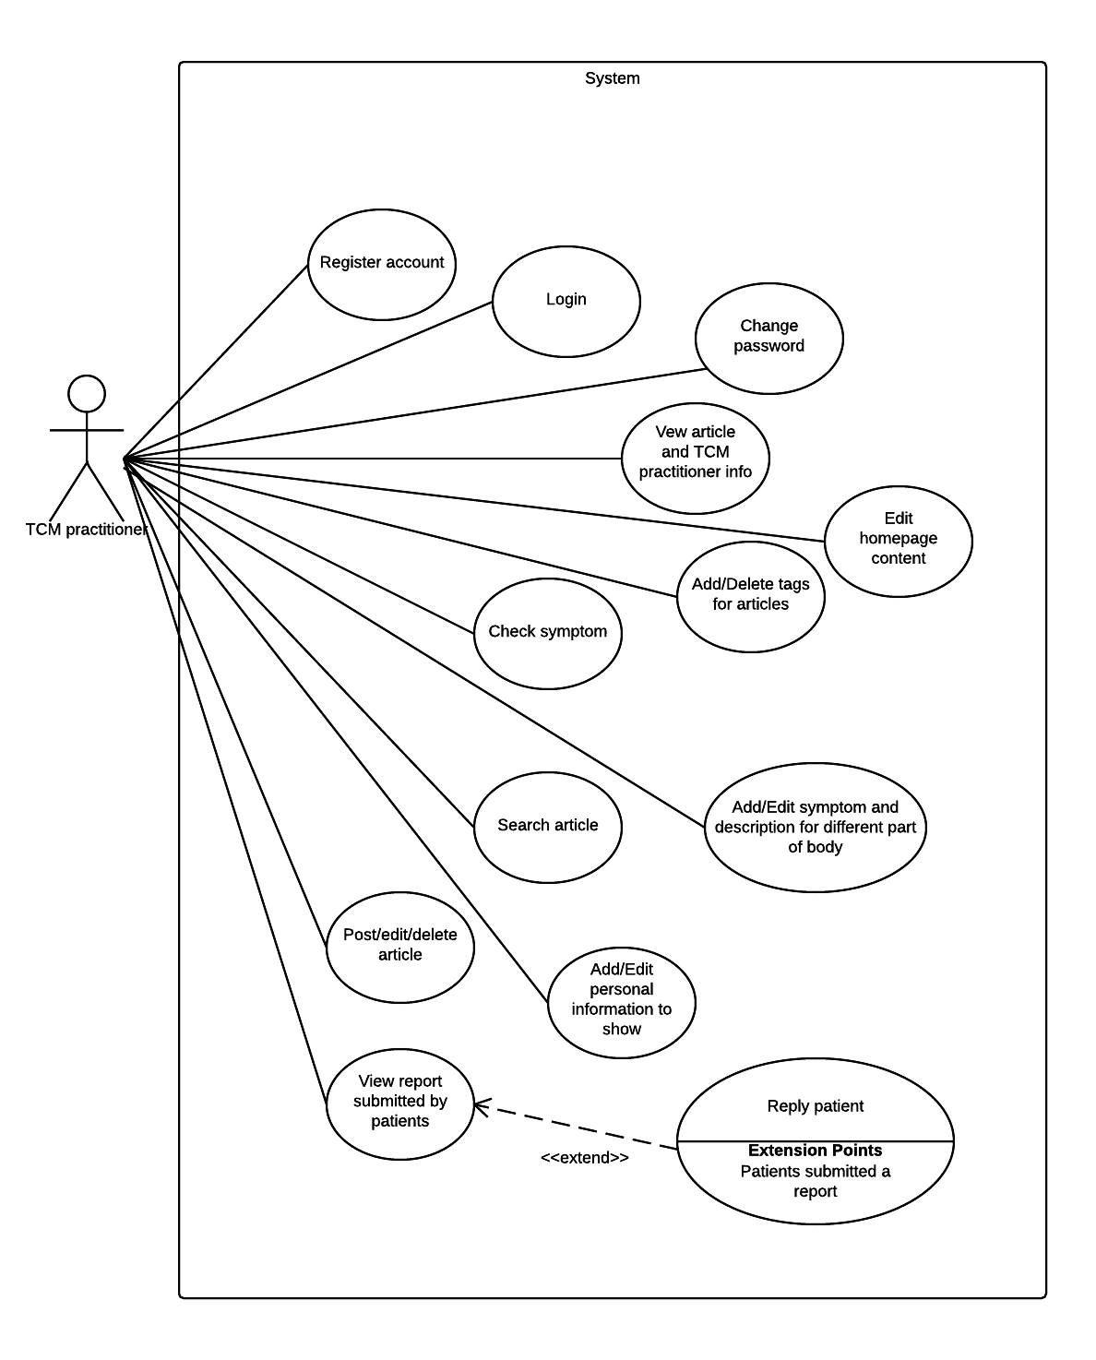

**Figure 4.1 Use cases for TCM practitioner/admin**

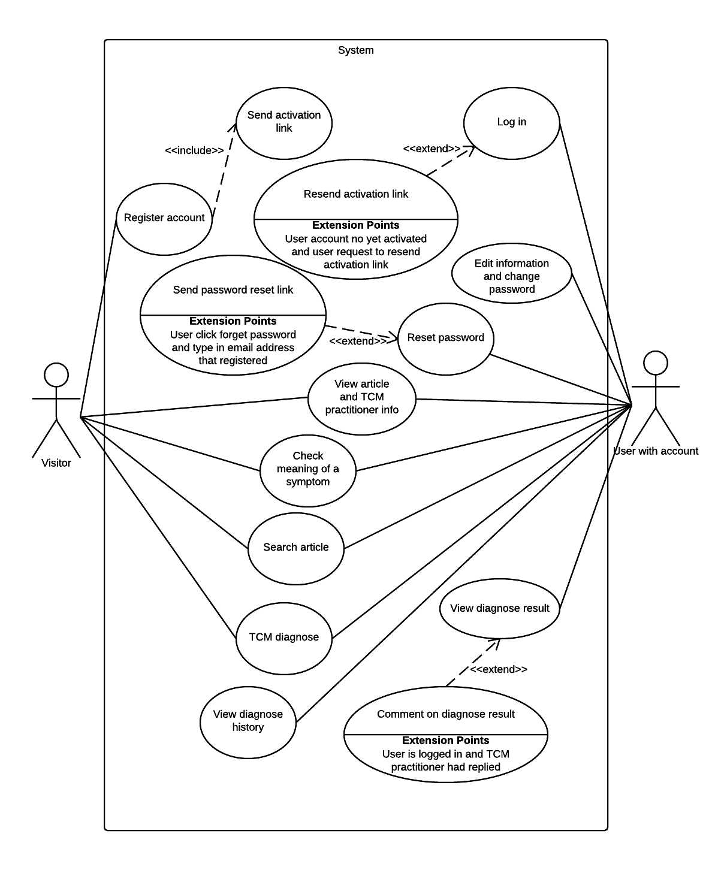

**Figure 4.2 Use cases for normal user/patient**

### Activity Diagram

Maria Ericsson, a principal consultant for IBM explain that an activity diagram is a simple and an illustration of what happens in a workflow, what activities can be done in parallel and whether there are alternative paths through the workflow. (Ericsson, 2004). Below are the activity diagrams for the system.

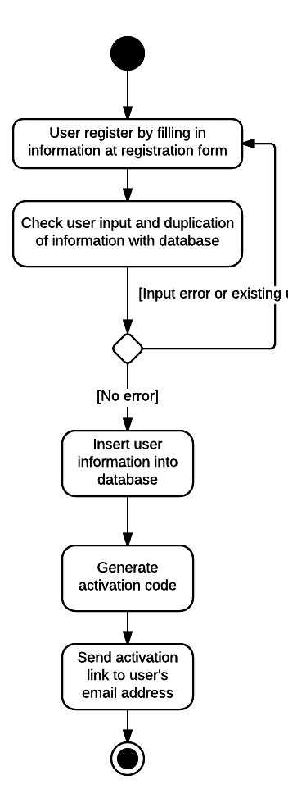

**Figure 4.3 Activity diagram of account registration**

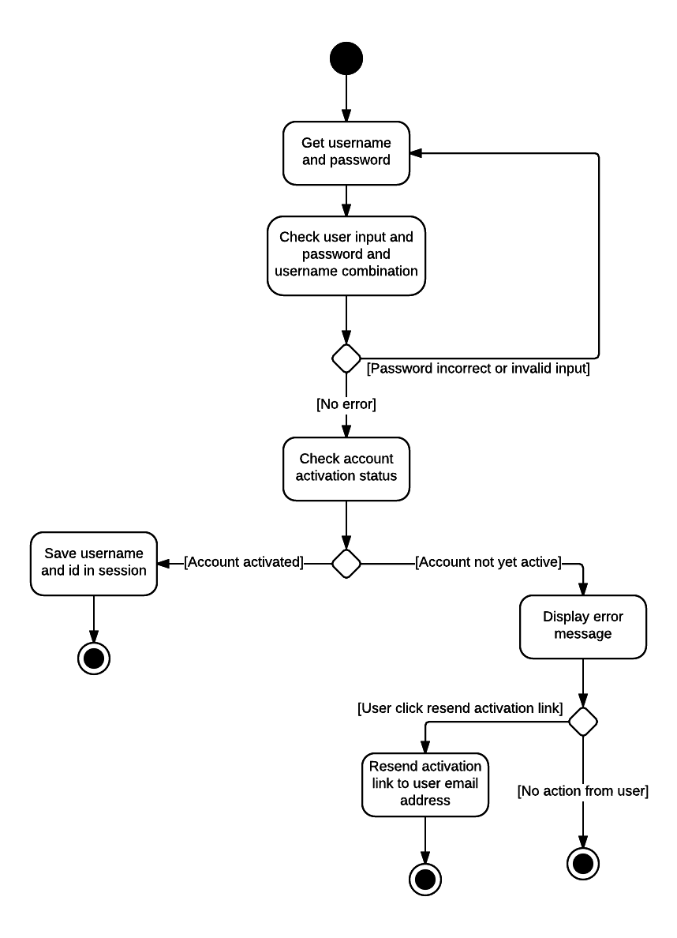

**Figure 4.4 Activity diagram of user log in**

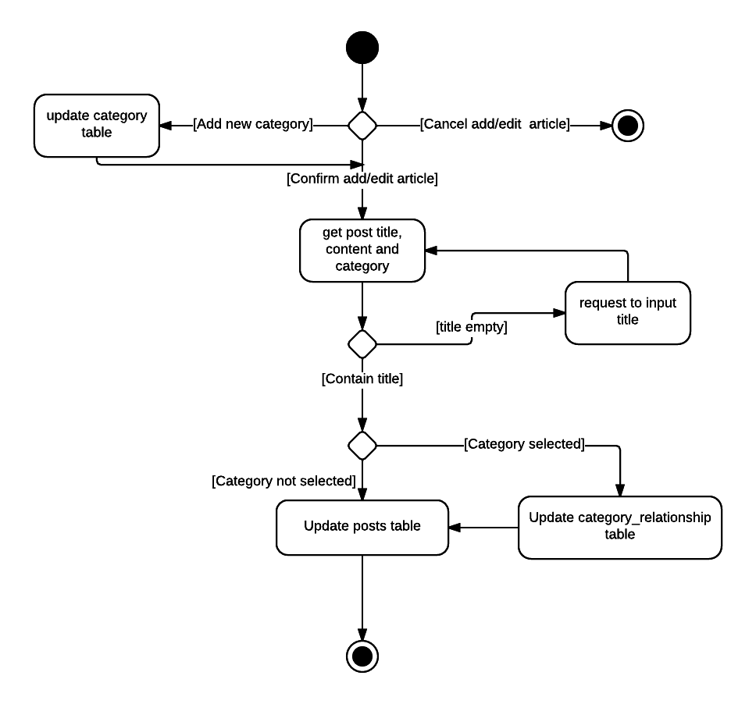

**Figure 4.5 Activity diagram of posting/editing article**

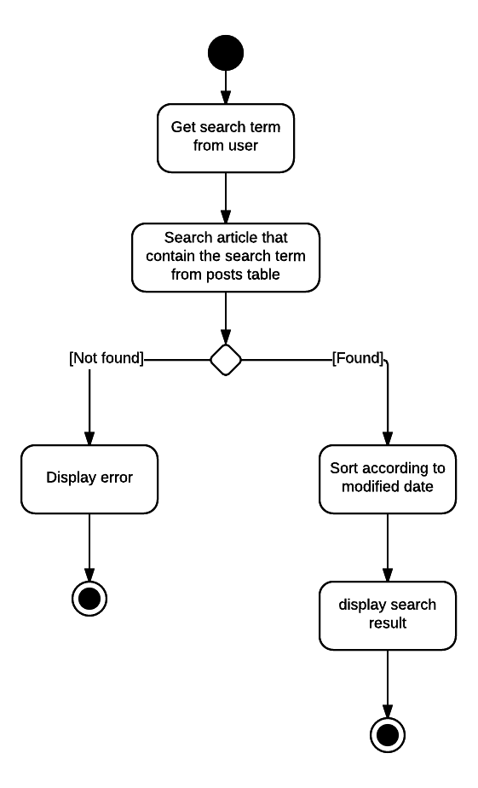

**Figure 4.6 Activity diagram of searching article**

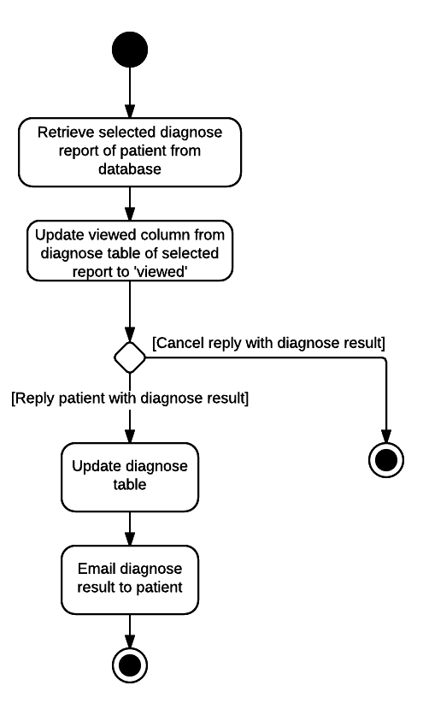

**Figure 4.7 Activity diagram of reply patient with diagnose result**

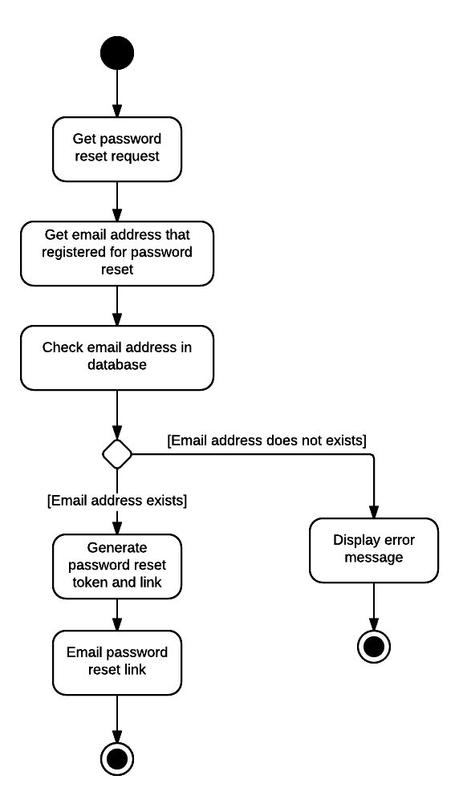

**Figure 4.8 Activity diagram of request password reset**

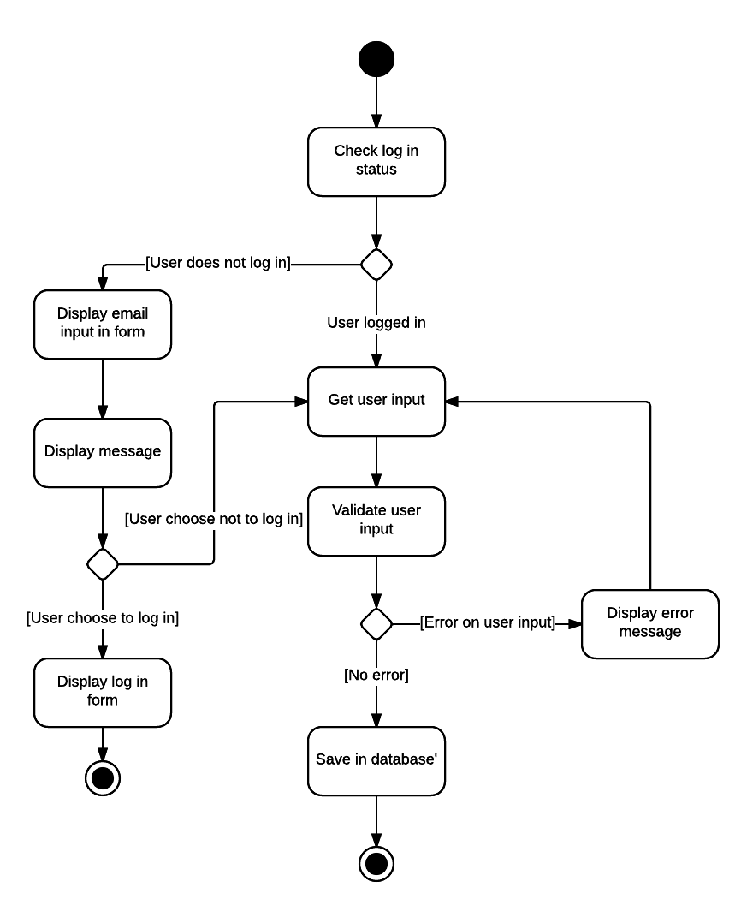

**Figure 4.9 Activity diagram of user submitting diagnose form**

### Database design

#### Entity Relationship Diagram

Figure below shows the ER Diagram of the system.

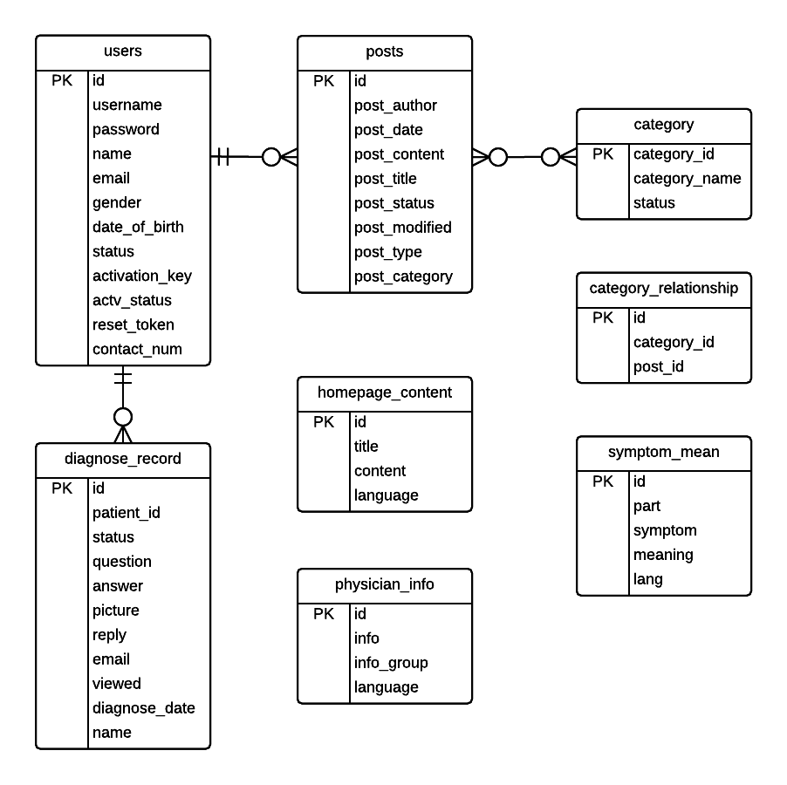

**Figure 4.10 ER Diagram**

#### Data Dictionary

Table below shows the description of attributes in every entity in database.

**Table 4‑1Data dictionary**

|  |  |  |  |
| --- | --- | --- | --- |
| **Entity Name** | **Attribute** | **Data Type** | **Description** |
| category | category_id {PK}  category_name  status | bigint  varchar  varchar | ID that uniquely identify a category.  Category’s name.  Status of a category, “delete” or “normal” |
| category_relationship | id {PK}  category_id  post_id | bigint  bigint  bigint | ID that uniquely identify a relationship between post and category  ID of a category in category’s table  ID of an article/post in posts table. |
| diagnose_record | id {PK}  patient_id  status  question  answer  picture  reply  email  viewed  diagnose_date  name | bigint  varchar  varchar  mediumtext  mediumtext  varchar  varchar  varchar  varchar  datetime  text | ID that uniquely identify a diagnose record.  User is that submitted the diagnose form.  Status of the diagnose record, “normal” or “archived”  Value of user submitted diagnose form in string format.  Diagnose result/reply from TCM practitioner/admin.  Path of tongue’s picture submitted by user.  To indicate whether TCM practitioner/admin reply to the patient’s question.  Email address of patient.  To indicate whether TCM practitioner/admin has view the diagnose question.  Date of diagnose question submitted.  Name of the diagnose question. |
| homepage_content | id {PK}  title  content  language | int  varchar  mediumtext  varchar | ID that uniquely identify a homepage contet.  Title of the content.  Content  To indicate is in English or Chinese. “en” for English and “cn” for Chinese. |
| physician_info | id {PK}  info  info_group  language | bigint  mediumtext  varchar  varchar | ID that uniquely identify the physician’s information.  The content.  To show which group the information belongs to.  To indicate is in English or Chinese. “en” for English and “cn” for Chinese. |
| posts | id {PK}  post_author  post_date  post_content  post_title  post_status  post_modified  post_type  post_category | bigint  varchar  datetime  mediumtext  text  varchar  datetime  varchar  varchar | ID that uniquely identify a post/article.  Author of post/article.  Post/article published timestamp.  Content of post/article.  Title of post/article.  Status of post/article, “normal” or “delete”.  Timestamp of post/article modified.  To indicate is post/article or something else.  Categories/tags a post/article belongs to in string format. |
| symptom_mean | id {PK}  part  symptom  meaning  lang | bigint  varchar  varchar  mediumtext  varchar | ID that uniquely identify a symptom.  Part of body.  Symptom  Meaning/description of symptom.  To indicate is in English or Chinese. “en” for English and “cn” for Chinese. |
| users | id {PK}  username {UQ}  password  name  email {UQ}  gender  date_of_birth  status  activation_key {UQ}  actv_status  reset_token {UQ}  contact_num | bigint  varchar  varchar  varchar  varchar  varchar  varchar  varchar  varchar  varchar  varchar  varchar | ID that uniquely identify a user.  Username of user  User’s password encrypted using cryp()  Name of user.  Unique email address of user.  Gender of user.  Date of birth.  Status of user. “user” or “admin”  Unique code that attach to URL and email to user after register for verification purpose.  To indicate whether user verify the email or not.  Unique random code that generate when user want to reset password.  Contact number of user. |

### Storyboard design

Storyboard illustrate the screen that user will go through for a specific purpose. The storyboard design will be cover in this section.

## IMPLEMENTATION

### Introduction

This chapter will discuss about the tools and technology that are used for the implementation of the system.

### Development tools and technology

#### Hyper Text Markup Language (HTML)

HTML provides the structure of webpage and is a set of markup language for describing web documents. (w3schools, n.d.). It will inform a web browser on how to display the content to people who view the specific page.

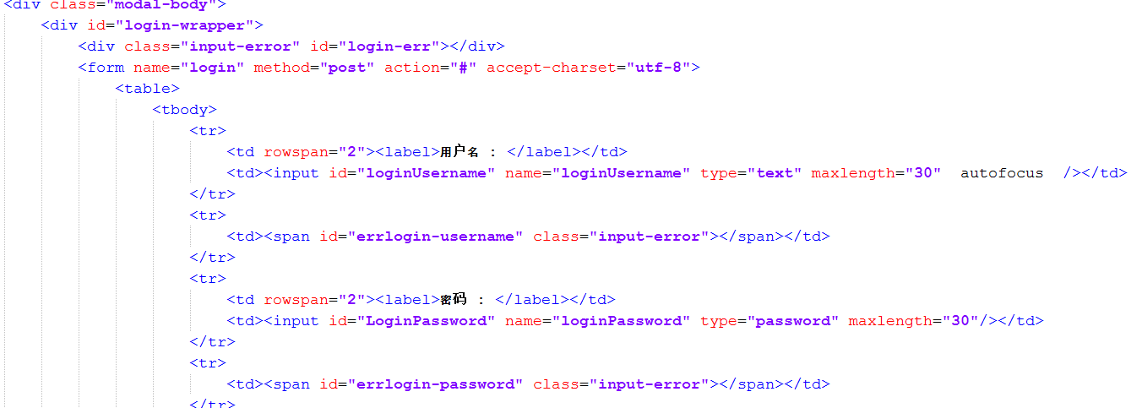

**Figure 5.1 HTML code to display log in form**

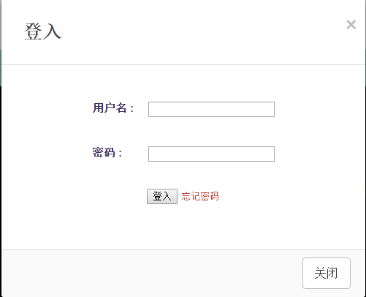

**Figure 5.2 Log in box of system**

The two diagrams above show the HTML code and the result that display on web browser of cause with the help of CSS which is use for styling the element display by HTML. CSS will be explain in next section.

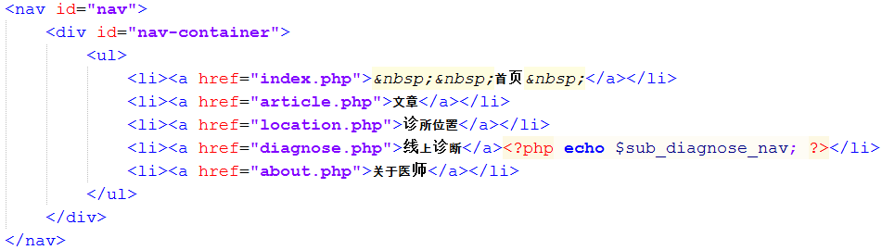

**Figure 5.3 HTML code to display the navigation bar**



**Figure 5.4 Navigation bar that created by HTML code**

Diagrams above show the HTML code and the result create by the code that render on web browser. It was also styled by CSS.

#### Cascading Style Sheets

Cascading Style Sheets (CSS) is a language which is use to define how a web page to present including layout, colours and fonts. (W3C, 2014). It can be store either externally as a .css file or internally with the HTML code. If the cascading style sheets are store externally the properties can be share by all the element of HTML as long as the path to the css files are included in every HTML pages.

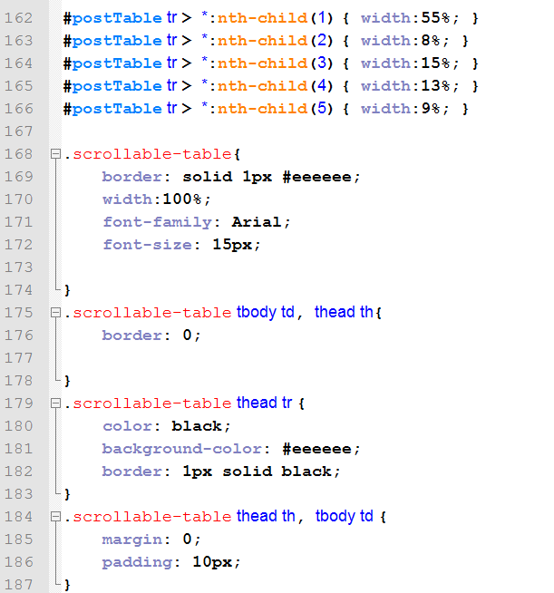

**Figure 5.5 CSS used in this system**

Diagram above show a small portion of the CSS that share among this system.

#### Hypertext Preprocessor (PHP)

PHP was chosen as a server side scripting language in this project which allow client (web browser) to communicate with the database either to store or retrieve data. Server side scripting is important to make a web page dynamic.

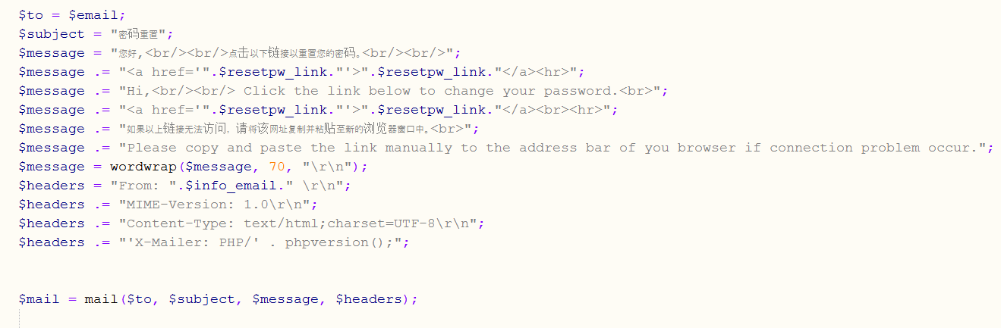

**Figure 5.6 PHP code that send password reset link email**

Diagram above show the PHP code that will send a password reset link to users’ email address that allow users to input a new password when they forget their log in password.

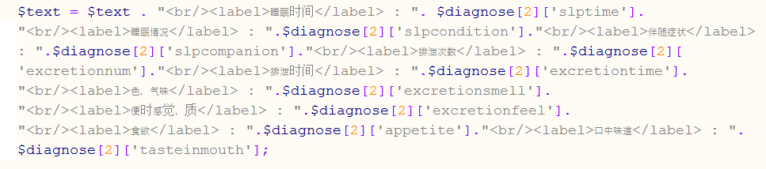

**Figure 5.7 PHP code that combine user input into desired format to store in database**

The diagram above shows the code for combining input value from users’ submitted form into a string with the desired HTML format before store in database.

#### MySQLi

MySQLi which also known as MySQL improved. It is an improved version of MySQL which is one of the most widely used DBMS (Database Management System) for web application. It is also an extension for PHP. Some features of MySQLi are:

* Easier to use as it is in Object oriented interface
* Support prepared statements thus help to secure the code
* Support multiple statements which allow to run more than one query at a time

MySQL not only has an object oriented interface, it also has a procedural interface which make it even more widely usable. (Mike, 2011)

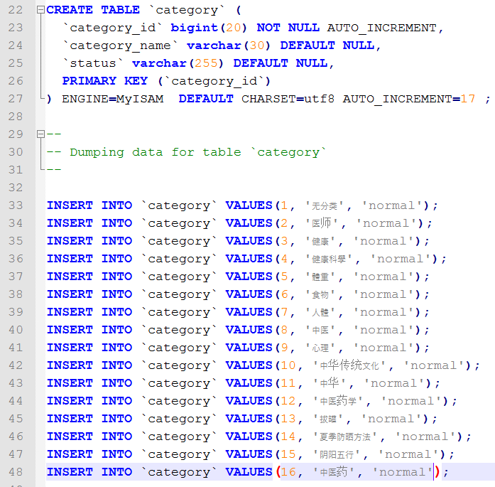

**Figure 5.8 Query to create table and insert data into table**

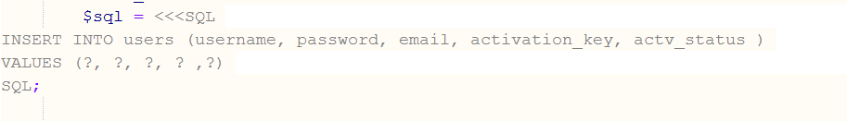

**Figure 5.9 Query in PHP to insert data in database using prepared statement**

#### JavaScript

JavaScript is the programming language that uses on client side designed to perform dynamic tasks with high interactivity options. It is embedded in HTML pages and runs on the visitor’s computer which does not require frequent download from website. JavaScript is also platform independent as it can run on any web browser as long JavaScript is enabled. (Chapman, n.d.) (php, n.d.)

JavaScript is used in many parts of this system such as display and hide log in and register form, append more text input in form, input validation, slide show and many more.

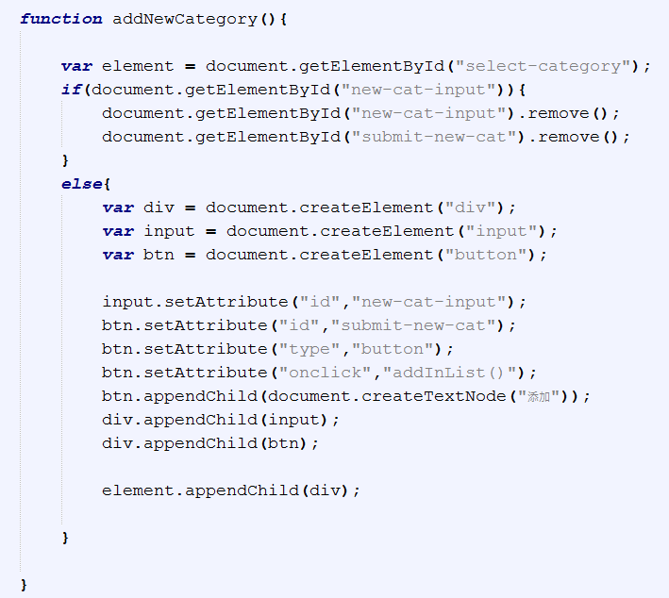

**Figure 5.10 Code to add a new input field**

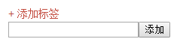

**Figure 5.11 Input field is added**

The diagrams above show the code and the input field that created after clicking the words in red which will trigger the JavaScript code and the input field will be removed if the words in red is clicked again.

#### WampServer

This system will be developed on the local machine before it is uploaded to an online web hosting server. WampServer ships with Apache, MySQL and PHP/phpMyAdmin and WampServer will be used as a web development environment which serve as a local host that will allow to create a web application with Apache (Web server or HTTP server) using PHP and establish connection to the MySQL database. Besides that, phpMyAdmin allows developers to manage the database easily. (Romain Bourdon, n.d.)

#### ToolHeap: Test Mail Server Tool

Test Mail Server Tool is a full featured mail (SMTP) server emulation to test mail sending capabilities of a web or desktop application or to preview messages before they are actually sent. This tool is required is this project because this project is developed on local host which need a lot of complex configuration if want to send an email. This tool solve the problem which allow the PHP mail() function to send email without complex configuration on local host setting.

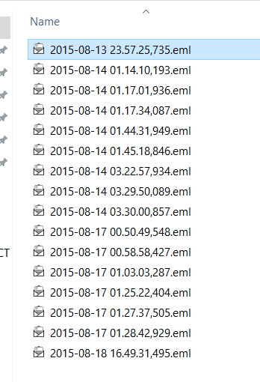

**Figure 5.12 Mails send to local server**

Figure above show the emails send through PHP mail() function in .eml file format.

### Implementation flow

The first thing to do for the implementation of the system is to create a database with the entities and attributes. After all the database is created, the interface of the system is created and then the database is reviewed and tested to make sure that all the entities and attributes are correctly created.

After that, the page for admin which will be the TCM practitioner will be created first. This is just a precaution steps to make sure that it will not mix up with another page that's accessible by normal user because normal user are not allowed to visit certain pages that only admin can visit such as posting and editing articles.

After all the pages are created, the main functionality of a specific page is implemented by using JavaScript and PHP code. All the functionality of a page will be tested before proceed to the next function. Lastly, all the parts and page are combined to form a complete system.

### Code and justification

Important functionality, codes and logic will be discussed in this section. Only some codes will be presented here as many of the other codes are having almost same flow and logic.

#### Commonly used variable and setting

There is a PHP file named common.php that contain settings or some commonly used variable such as database name, database password, database user, database host, email address, server time zone and etc. The reason having this file is because if any changes or modification like changing hosting server, website URL, time zone, number of posts to display on a page and it can be easily modified here instead of searching deeply into a specific PHP file. Whenever these variables are required in any part of a PHP file what to do is just include this common.php using PHP code include (“path/common.php”);

#### Connect to database

A connection to the database must be established before manipulating the data in the database. The PHP code below to show the connection to the database by using the PHP default function, mysqli () with four parameters, location of the server, database’s username, database’s password and database’s name. The charset, which mean character encoding of the database must set to uft8 by calling the mysqli_set_charset () with parameter of database connection and utf8. This is because the database of this system will be stored in Chinese character.

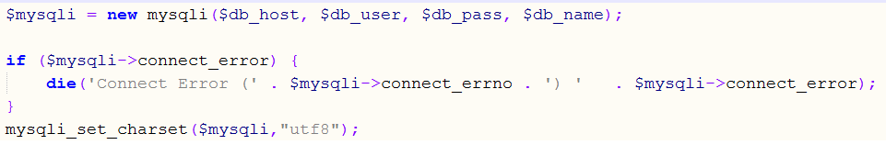

**Figure 5.13 PHP code used to setup connection to database**

#### Register

If patients want to get diagnose result from TCM practitioner before other patients that do not log in or they want to check on diagnose history, they need to log in into their account first to submit a diagnose form. In order to log in, users have to register for an account.

After a user fill in the registration form, all the details are passed to register.php through an AJAX request. If they are no problem with the details such as existing username or email address in the database or input error, the account details will be inserted into the database and an activation link will be generated and send to the registered email address by running the code in send_activation.php. Then a pop out box will appear and inform the user to proceed to their email inbox to verify the email address. A user only can log in their account after they verify their email address by clicking the verification link that email to their mail box.

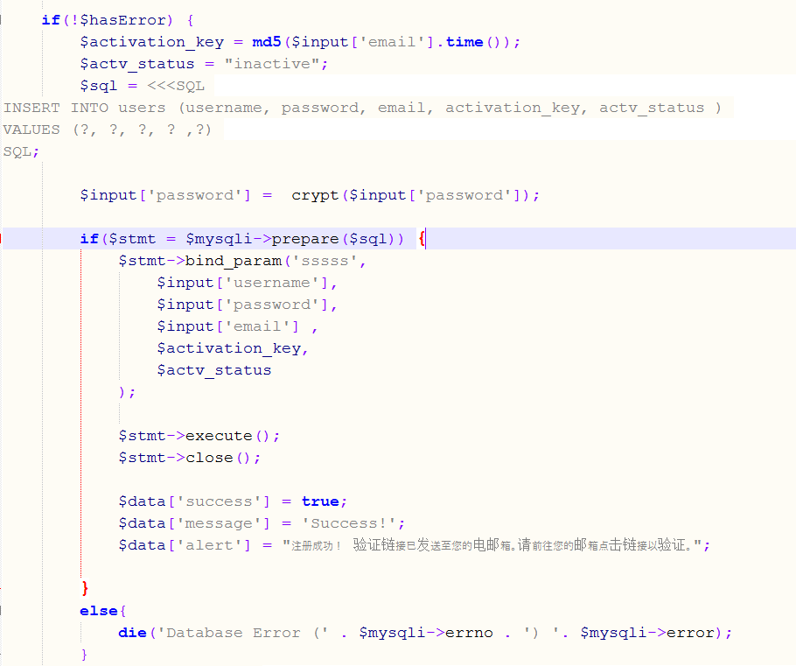

**Figure 5.14 Part of the code in register.php**

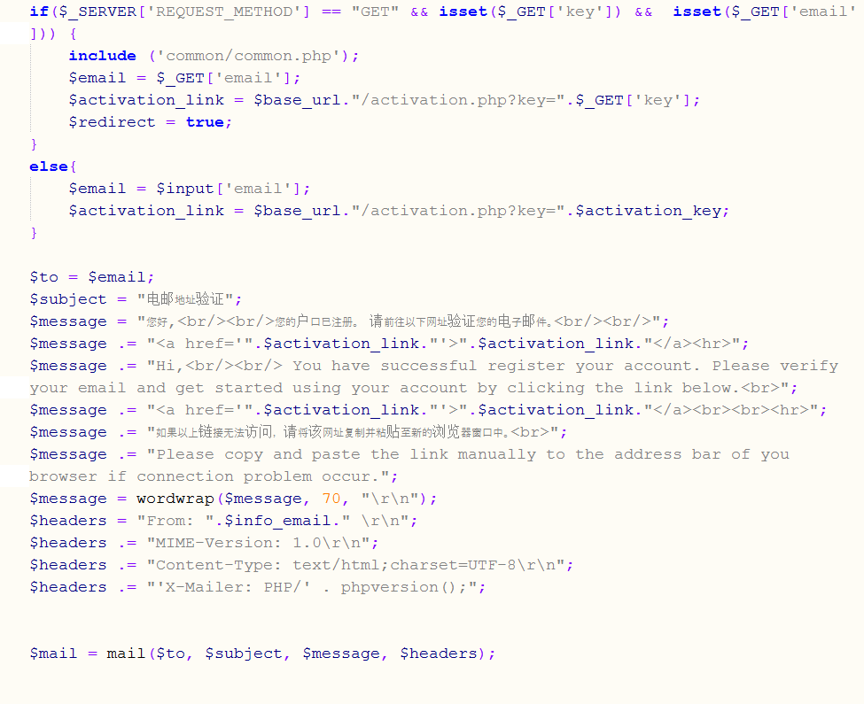

**Figure 5.15 Part of the code of send_activation.php**

#### Log in

After user fill in the username and password in log in form, the details are again passed by AJAX to login.php. The reason why use AJAX to pass the value is the same as using it at the registration part. AJAX allows to exchange data with server or updating part of a web page behind the scene which mean without reloading the whole page so the error message of login details can display using JavaScript without reloading the whole page and clear the user input. (w3schools, n.d.).

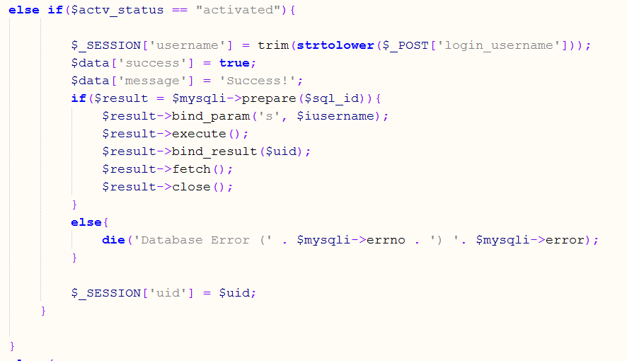

**Figure 5.16 Part of code showing no error on login details**

The figure above shows that if no error on combination of password and username and account if activated by verify email address, the username and id are then saved using $_SESSION[] array until the user log out or close the browser. If the username and password combination is wrong, an error message will display to the user. If user haven’t verified their email address, a message will display and user can choose to resend the verification link in case they did not receive the email.

If the username is hanqi which will be the admin, the system will direct the page to admin-access only page.

#### Display article (SELECT)

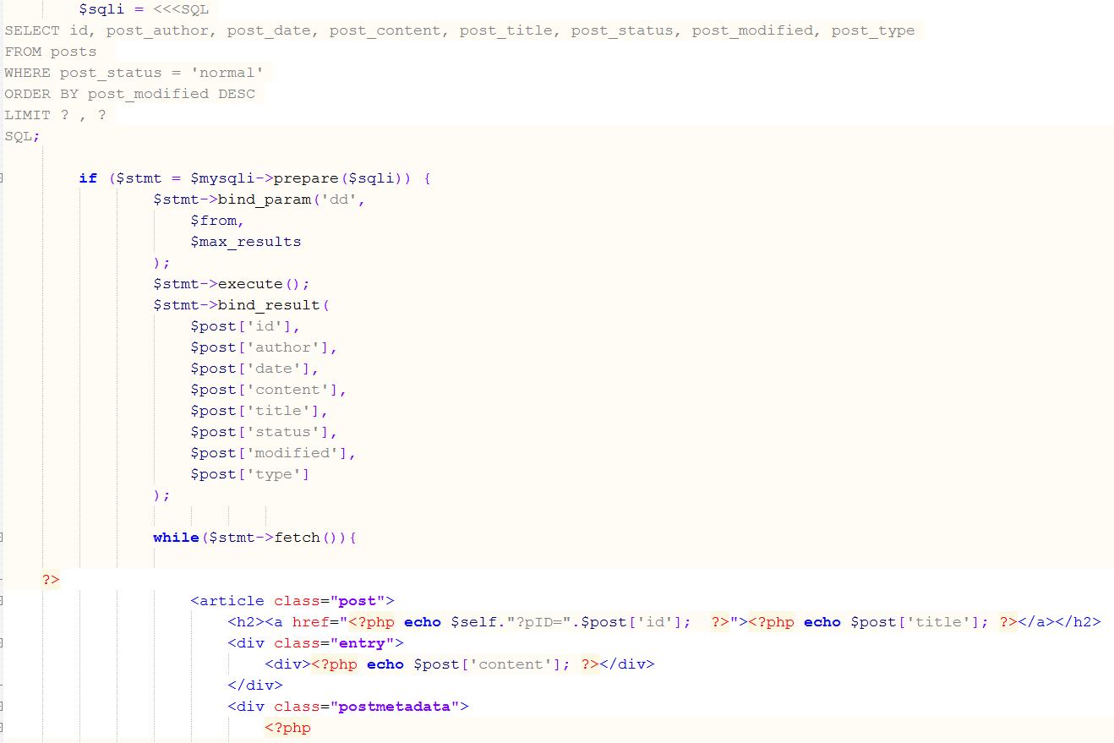

**Figure 5.17 Display article**

The posts.php is included in article page to select articles that is not deleted from the posts table in database and display it using SELECT query and the condition is post_status = “normal” and article with latest edit will be display on top. The number of articles to select and display is limited by the variable $max_results in common.php. Every article that fetches from the database will be displayed in HTML and this fetching steps are loop until no more result to fetch from the SQL statement.

#### Post new article (INSERT)

A page name post-new.php is in a folder named admin that only accessible by admin. Before submitting the new article to insert into database, admin is allowed to choose or add new category(s)/tag(s) for the article. Whenever admin adds a new tag/category, it will call to addNewCategory.php using AJAX to insert the newly added tag/category into the database so the page will still remain at the post-new.php.

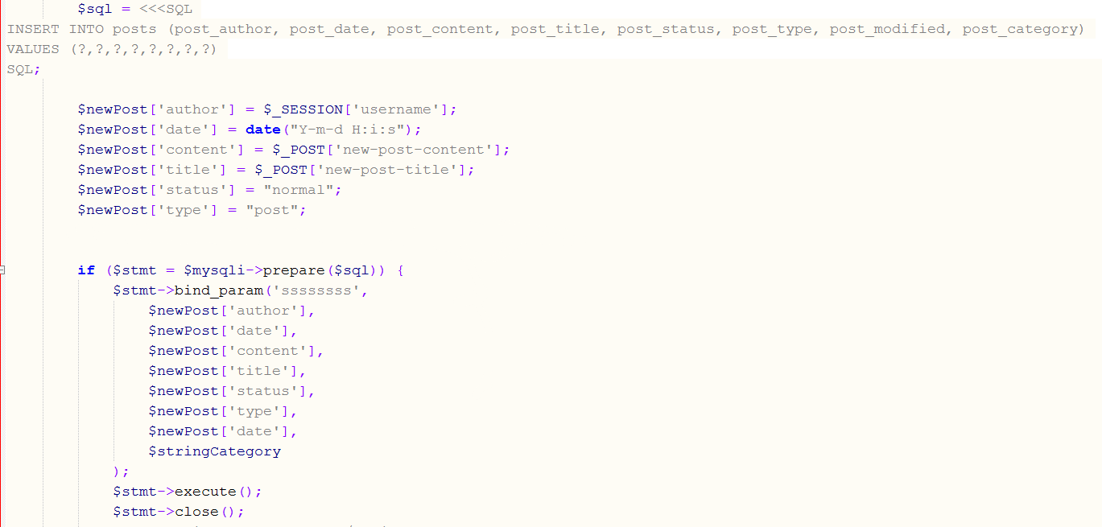

**Figure 5.18 Part of code in post-new.php**

Figure above shows the code for inserting a new article into database. If user selected any category/tag, category_relationship table in database will update with the post id and the category id.

#### Edit information (UPDATE)

Admin can edit their information, article or content in the homepage using UPDATE query. All of the update/edit pages only can be accessed by admin. For example, ad-editpost.php. In this page, all the content of selected article will be displayed in the input field then admin can make some changes of the content and update it in the database.

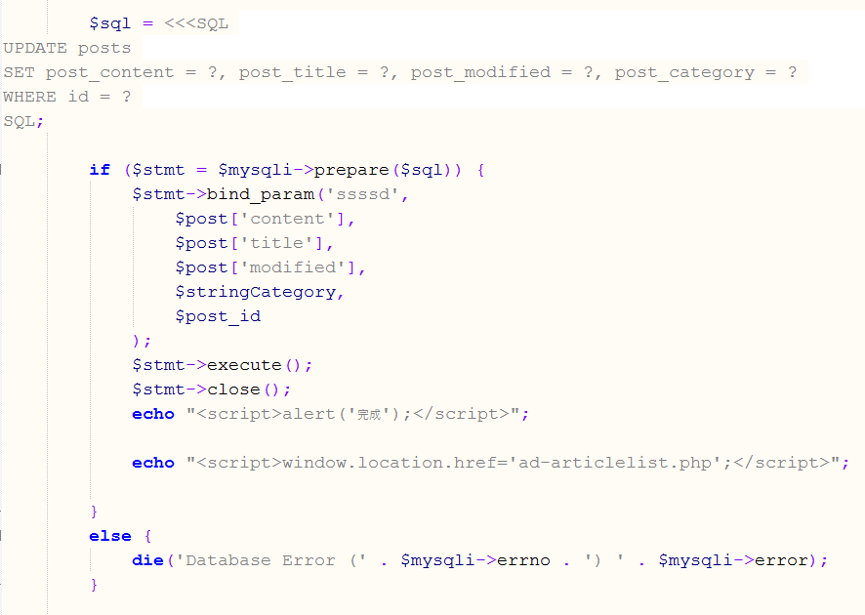

**Figure 5.19 Code to perform update posts table**

Figure above shows the query and statement to update existing content in the posts table. The flow of editing something is the same across the whole system which is: retrieve the previous content then update the newly edited content.

### Web hosting

Initially, the free web hosting server that chosen was serversfree but due to the server always down, the author decided to change to a new hosting server which is 000webhost. In order to let the system run on the server, there are some minimum requirement for the server which are: support PHP at least version5.0, support PHP mail() function and support MySQL.

The first thing to do is create an account at 000webhost then log in from “member area” as shown in the diagram below.

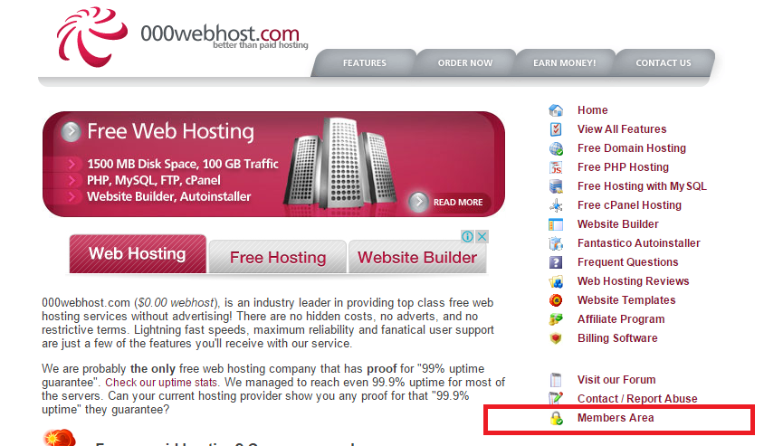

**Figure 5.20 000webhost log in**

#### Domain name

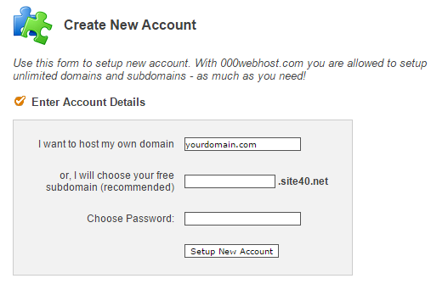

**Figure 5.21 Create account for new website**

After create an account at 000webhost, an account for a website need to create too. Customer can choose to either use their own domain name or use a free subdomain provide by 000webhost.

#### Upload and manage web page files

After logging in proceed to the CPanel, which will be a page for configuration and setting of website then choose “1-Click Website Restore” to upload all the web site files but before that, all the files must be compress in .zip format. Besides upload the web site from CPanel, it can be upload and manage through a third party FTP program such as FileZilla. The information for the FTP account can be view at “FTP login and Upload Details” page.

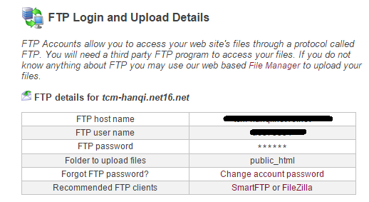

**Figure 5.22 FTP account details**

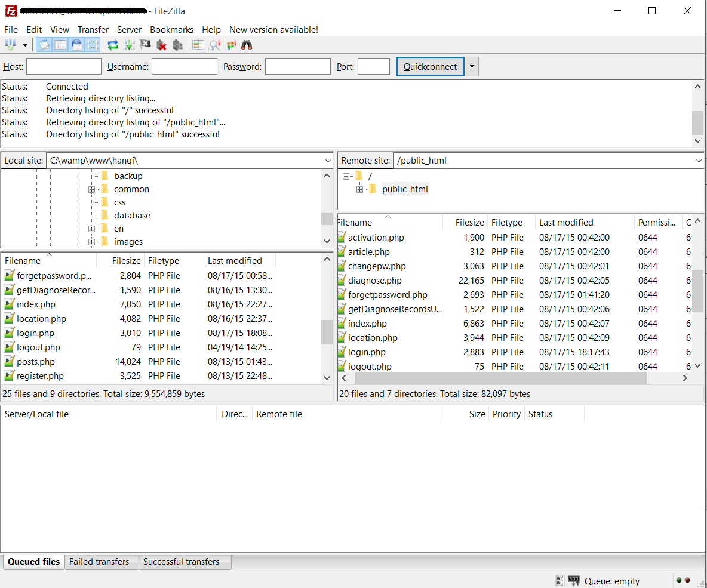

**Figure 5.23 FileZilla**

FileZilla allows to edit/view/delete files but there is also a file manager for the website that can access through CPanel.

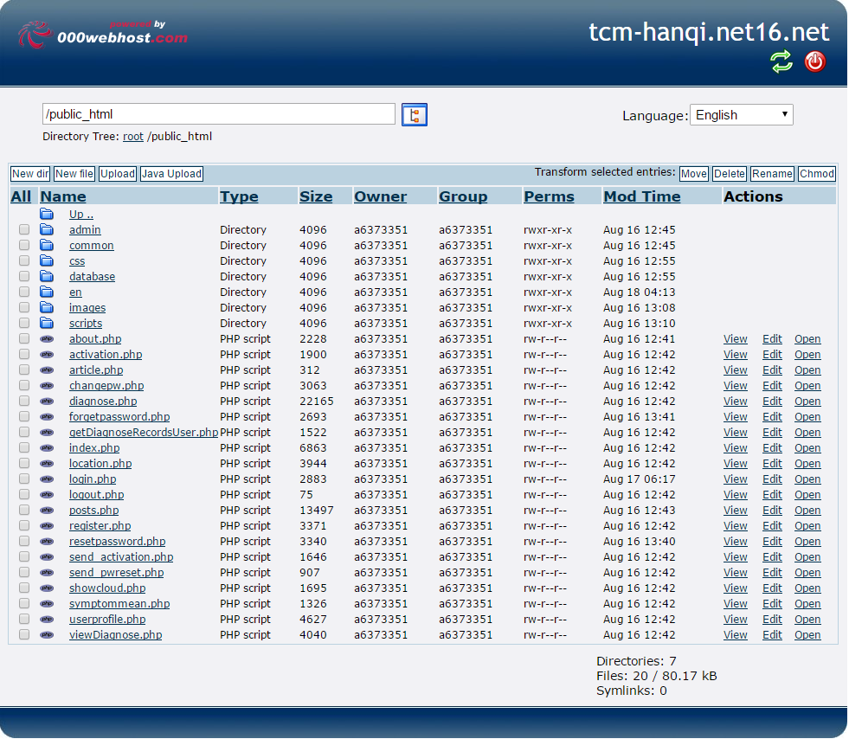

**Figure 5.24 File manager of 000webhost**

From this file manager, all the files can be view, edit or delete or upload a new web page file just like from the FTP program. Lastly, all the website files must be upload to public_html folder otherwise the website will not work.

#### Database

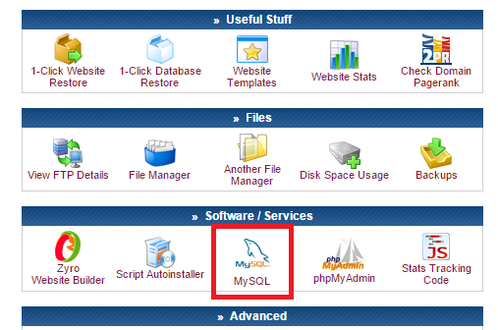

**Figure 5.25 000webhost database**

To create a database for a website hosted at 000webhost is just like creating a database on local host. Database name, database username and password are needed in order to create a database.

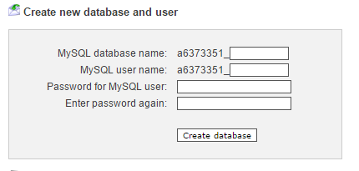

**Figure 5.26 Create database**

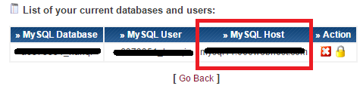

**Figure 5.27 List of database created and details**

In figure 5.25, column in red box will be the address of the host database which will be needed when connecting the website to database and also the database name, username and password that use to create the database will be needed too. All of these values have to be assign to db_host, db_user, db_pass, db_name in common.php.

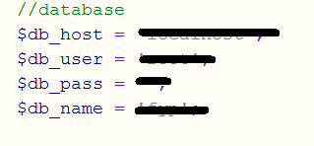

**Figure 5.28 Assign value of database details in common.php**

The database that created can be manage through phpMyAdmin. It can create/drop/alter tables, delete/edit/add fields, execute any SQL statement, and manage keys on fields.

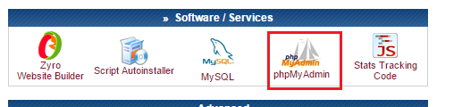

**Figure 5.29 phpMyAdmin in 000webhost**

#### Email account

Most of the free web hosting servers will provide customer some email account with the domain name of the website. 000webhost provides up to 5 emails account for customer to create. Email account can manage through “Email” section.

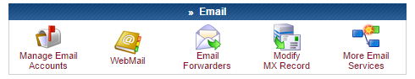

**Figure 5.30 Email**

## TESTING

### Introduction

Quality assurance is important to make sure that the software developed is bugless. Testing is one of the methods to ensure the quality of a software.

In this chapter, the tests that will be carried out are:

* Unit testing
* Integration testing
* User Acceptance testing

### Unit testing

 A unit is the smallest testable part of a software or system like functions, classes, procedures, interfaces. Unit testing is a method to test every individual units of source code are fit for use. (ISTQB EXAM CERTIFICATION, n.d.). Unit tests are always performed by the developers to check the design of the unit and to prove that the code that are testing does what the developers expect. (Lorenz, 2014). Unit testing for this project was conducted on local host.

#### Unit testing on register and log in

|  |  |  |  |
| --- | --- | --- | --- |
| **Test case** | **Execution steps** | **Expected result** | **Pass/Fail** |
| Database connection | 1. Run the application 2. Look for error message | Connection to the database should be successful without error. | Pass |
| Register with error input | 1. Fill in information in registration form with some invalid input such as invalid email address format | Display error message and new user’s details will not add into the database. | Pass |
| Register with correct input | 1. Fill in information in registration form with valid input | Display success message and add new user’s details into the database. | Pass |
| Log in with correct combination of username and password | 1. Fill in correct username and password | Display message if email address not yet verify. Save username in session if email already verified. | Pass |
| Log in with incorrect combination of username and password | 1. Fill in incorrect combination of username and password | Display error message. | Pass |

#### Unit testing on article

|  |  |  |  |
| --- | --- | --- | --- |
| **Test case** | **Execution steps** | **Expected result** | **Pass/Fail** |
| Database connection | 1. Run the application 2. Look for error message | Connection to the database should be successful without error. | Pass |
| Insert article into the database | 1. Insert some value in text field. 2. Press confirm button | Database “posts” table should have the value that inserted. | Pass |
| Retrieve article to edit | 1. Select article to retrieve | All the content should display on desire area. | Pass |
| Edit article | 1. Select article to edit 2. Make some changes to the content or title 3. Press confirm button | Edited article should display the content and title with the latest edit. | Pass |
| Delete article | 1. Click on delete button | The status of a deleted article should change to “delete”. | Pass |
| Search article | Provide keyword to search in the search box. | Articles that contain the search keyword should be able to retrieve. | Pass |

#### Unit testing on diagnose section

|  |  |  |  |
| --- | --- | --- | --- |
| **Test case** | **Execution steps** | **Expected result** | **Pass/Fail** |
| Database connection | 1. Run the application 2. Look for error message | Connection to the database should be successful without error. | Pass |
| Check for log in status | 1. Go to diagnose page without log in | An input field that requires user to enter email address will appear and when click on the form, a message box will pop out ask to log in or not. | Pass |
| Check for log in status | 1. Go to diagnose page after log in | Input field for email address will not appear. | Pass |
| Submit form | 1. Fill in the diagnostic form 2. Enter correct captcha value 3. Press submit button | The new record will be inserted into the database | Pass |
| View diagnose record | 1. Log in as admin 2. Go to diagnose list page | Submitted diagnose request of the patients will display | Pass |
| View diagnose record | 1. Log in as normal user 2. Submit a diagnose form 3. Go to diagnose history page | Submitted diagnose request will display | Pass |
| Reply patient with result | 1. Log in as admin 2. Go to diagnose list page 3. Click on one of the submitted diagnose request 4. Type some words and press confirm | Status of the diagnose request will change to “read” and “replied” and updated with diagnose result and email with diagnose result will receive using Test Mail Server Tool. | Pass |

#### Unit testing on symptom checker

|  |  |  |  |
| --- | --- | --- | --- |
| **Test case** | **Execution steps** | **Expected result** | **Pass/Fail** |
| Database connection | 1. Run the application 2. Look for error message | Connection to the database should be successful without error. | Pass |
| Display symptom | 1. Select a body part | All the symptom on the selected part will display in a new added drop down list | Pass |
| Display meaning | 1. Select a symptom | Meaning of symptom will display. | Pass |

#### Unit testing of content in homepage and about Han Qi page

|  |  |  |  |
| --- | --- | --- | --- |
| **Test case** | **Execution steps** | **Expected result** | **Pass/Fail** |
| Database connection | 1. Run the application 2. Look for error message | Connection to the database should be successful without error. | Pass |
| Retrieve content | 1. Run the application 2. Go to homepage | All the content for homepage from the database should display. | Pass |
| Retrieve content | 1. Run the application 2. Go to “about Han Qi” page | All the content of this page from the database should display. | Pass |
| Edit content | 1. Log in as admin 2. Go to “setting” page 3. Click “edit” on section wan to edit 4. Press confirm button after editing | Edited content should be updated in database in correct table | Pass |

#### Unit testing on navigation link

|  |  |  |  |
| --- | --- | --- | --- |
| **Test case** | **Execution steps** | **Expected result** | **Pass/Fail** |
| Hypertext navigate function | 1. Click edit on selected homepage content | Direct to correct page with correct content retrieve from the database. | Pass |
| Hypertext navigate function | 1. Click edit or link to the selected article | Direct to correct page with the correct article retrieve from the database | Pass |
| Hypertext navigate function | 1. Click edit or link on selected TCM practitioner information | Direct to correct page with correct content retrieve from the database. | Pass |
| Menu bar navigation | 1. Click homepage on menu bar and footer site-map | Direct to homepage | Pass |
| Menu bar navigation | 1. Click article on menu bar and footer site-map | Direct to article page | Pass |
| Menu bar navigation | 1. Click location on menu bar and footer site-map. | Direct to location page | Pass |
| Menu bar navigation | 1. Click diagnose on menu bar and footer site-map. | Direct to diagnose page | Pass |
| Menu bar navigation | 1. Click about HanQi on menu bar and footer site-map. | Direct to about HanQi page | Pass |
| Change language | 1. Click on “Chinese” or “English” link. | Direct to English/Chinese page | Pass |

### Integration testing

Integration testing is a level of software testing where every single unit is combined as a group and tested. The purpose of this level of testing is to discover errors in the interaction between integrated units. (STF, 2011). Integration testing of this system was performed on both localhost and online server.

Below are the testing done.

Test case 1:

|  |  |
| --- | --- |
| **Test case** | Reset password if users forget their password |
| **Test Performed** | Steps:   1. Click on “log in” on top right corner.      1. Click “forget password”. 2. Enter registered email address.      1. Go to email inbox and click on the verification link.      1. Click on the link and will direct to the password reset page.      1. Enter new password. |
| **Expected Result** | * + - 1. After clicking the “log in”, a log in box will appear.       2. After “forget password” is clicked, it will direct to another page to allow input email address.       3. After submitting the email address, a link will send to the email address.       4. The verification link that sends to the user will direct the user to a page that allow user to enter a new password.       5. Password successfully resets. |
| **Actual Result** | 1. After clicking the “log in”, a log in box appear. 2. After “forget password” was clicked, it direct to another page that allow input email address. 3. After submitting the email address, a link was sent to the email address. 4. The verification link that sends to user direct to a page that allow user to enter a new password. 5. Password successfully reset. |
| **Pass/Fail on local host** | Pass |
| **Pass/Fail on online server** | Pass |

Test case 2:

|  |  |
| --- | --- |
| **Test Case** | Posting a new article |
| **Test Performed** | Steps:   1. Log in as admin. 2. Go to post-new.php page by clicking “New Article” on the menu bar. 3. Insert title and content and select some tags.      1. Press confirm button. |
| **Expected Result** | 1. After logging in as admin, the “log in” word on top right corner will change to the username that use to log in and there are some extra links on the menu bar. 2. Click on the “New Article” on the menu bar and will direct to post-new.php. 3. After press the confirm button, the new article will be added into the database. 4. New article can be viewed on “Article” page and the title of the article can see on “Article List” page. |
| **Actual Result** | 1. After logging in as admin, the “log in” word on top right corner changed to the username that use to log in and there are some extra links on the menu bar. 2. Click on the “New Article” on the menu bar and it direct to post-new.php. 3. After the confirm button was pressed, the new article is added into the database. 4. New article appears on “Article” page with the correct information and the title of the article appears on “Article List” page. |
| **Pass/Fail on local host** | Pass |
| **Pass/Fail on online server** | Pass |

Test case 3:

|  |  |
| --- | --- |
| **Test Case** | Editing an article |
| **Test Performed** | Steps:   1. Log in as admin. 2. Go to article page and click on “edit” button next to the article title or go to “Article List” page by clicking “Article List” on menu bar then click on title of article want to edit.      1. It will direct to a page with all the content of the article shows in input field. 2. Edit the content and title and also tags.      1. Press confirm button. |
| **Expected Result** | 1. After logging in as admin, the “log in” word on top right corner will change to the username that use to log in and there are some extra links on the menu bar. 2. After clicking the edit button on “Article” page or the article’s title of article want to edit, it will direct to edit page with content and title loaded. 3. After press the confirm button, all the changes will update in the database. |
| **Actual Result** | 1. After logging in as admin, the “log in” word on top right corner changed to the username that use to log in and there are some extra links on the menu bar. 2. After clicking the edit button on “Article” page or the article’s title of article want to edit, it directed to edit page with content and title loaded. 3. After press the confirm button, all the changes are updated in the database. |
| **Pass/Fail on local host** | Pass |
| **Pass/Fail on online server** | Pass |

Test case 4:

|  |  |
| --- | --- |
| **Test Case** | Submit a diagnose form as member |
| **Test Performed** | Steps:   1. Log in as a registered member with email address verified. 2. Go to “diagnose” page by clicking on “diagnose” on the menu bar. 3. Fill in all the information. 4. Press submit button. |
| **Expected Result** | 1. Username will be shown on top right corner after log in. 2. A questionnaire form will display on diagnose page. 3. After submitting the form, the form can be viewed from “diagnose history” page. |
| **Actual Result** | 1. Username shown on top right corner after log in. 2. A questionnaire form displayed on diagnose page. 3. After submitting the form, the form can be viewed from “diagnose history” page. |
| **Pass/Fail on local host** | Pass |
| **Pass/Fail on online server** | Pass |

Test case 5:

|  |  |
| --- | --- |
| **Test Case** | To reply a patient with diagnose result |
| **Test Performed** | Steps:   1. Log in as admin. 2. Go to diagnose history page by clicking “diagnose history” on the menu bar. 3. Select a problem want to reply.      1. Press confirm after reply. |
| **Expected Result** | 1. Diagnose history will appear in the menu bar after log in. 2. All the information will display after selecting a problem. 3. Database will update the status of reply to “replied” and the reply from Han Qi. 4. An email with the reply will automatically send to the email address provided by the patient (non-member) or the email address that patient used to register for account. |
| **Actual Result** | 1. Diagnose history appeared in the menu bar after log in. 2. All the information was displayed after selecting a problem. 3. Database updated the status of reply to “replied” and the reply from Han Qi. 4. Successful send an email on the local host with the reply automatically send to the email address provided by the patient (non-member) or the email address that patient used to register for account. 5. On online server, the email sometime does not send due the problem of server. |
| **Pass/Fail on local host** | Pass |
| **Pass/Fail on online server** | Email sometime send but sometime not. |

Test case 6:

|  |  |
| --- | --- |
| **Test Case** | Edit homepage content and practitioner information |
| **Test Performed** | Steps:   1. Log in as admin. 2. Go to setting page by clicking “setting” on the menu bar. 3. Select which content wants to edit. 4. Press confirm button after editing. 5. Repeat all the steps for all the other content and information. |
| **Expected Result** | 1. Successful log in as admin. 2. “Setting” appear on the menu bar. 3. Redirect to setting page after clicking “Setting” on the menu bar. 4. Click “edit” on content that want to edit will direct to a page with the content fill in the input area. 5. Successful update the edited content in database after pressing “confirm” button for every edited content and information. |
| **Actual Result** | 1. Successful log in as admin. 2. “Setting” appear on the menu bar. 3. Redirect to setting page after clicking “Setting” on the menu bar. 4. Click “edit” on content that want to edit and it direct to a page with the content fill in the input area. 5. Successful update the edited content in database after pressing “confirm” button for every edited content and information. |
| **Pass/Fail on local host** | Pass |
| **Pass/Fail on online server** | Pass |

### Acceptance testing

## CONCLUSION AND RECOMMENDATION

### Contribution of project

The main concern for this project is to customise a website the allow TCM practitioner, Chen Han Qi to share her knowledge to the public and allow people to submit a form with their health problem to let her diagnose in TCM way. Han Qi has not much experience in using the internet and don’t have much time for her to learn, so a website that customise for her will be the best choice for her to achieve her purpose. Besides that, she can also have all the features she want in just one system.

### Limitation of the system

One of the limitation is the project are hosted on a free server so the performance is an issue because the resources of the server is limited for a free account. The web page sometime will take long time to load and the disk space is only 15000MB with 100GB per month data transfer rate. The other issue for this web hosting server is the PHP mail () function sometimes does not work. This problem face by many users of 000webhost because there are many questions and complains about this in the forum of 000webhost. The other limitations are:

* Security issue. The security of this system is not strong enough to protect all the user’s details.
* Information display such as diagnose record need to organize in a much better way to provide a better view.
* 000webhost do not support the latest version of PHP thus some of the PHP functions from the latest version that can run on local host need to downgrade/modify in order for the system to run on the web server.
* Sections to check for meaning of a symptom are not detailed enough. Currently, all the symptoms of one part of the body are all in a same section to let users to choose.

### Future enhancement

For the enhancement in the future, the limitation of this system must be solve and more functionality should add in.

* Shift to a better web hosting server but it will mostly cost some monthly or yearly fee.
* Implement more security algorithm or plug-in.
* Break the symptom to more section so it can be more detail and specific.
* Design the web pages interface in a much more attractive way.
* Live chat session with TCM practitioner.

However, if more features are implement in the system, the complexity of the system will be increase which against the will of Han Qi which is simple and easy to use and users do not need to click too much on a web page but this is unavoidable and the author believe that Han Qi is still not familiar with technology nowadays but once she get used to it as long as the system is not too complicated, the complexity of system will not be an issue for her.

### Conclusion

In a nutshell, this project aims to provide a simple and easy to use environment for Chen Han Qi to share her knowledge and helping others to solve their health problem.

This project has been developed over a period of 8 months, starting from the submission of proposal to requirements gathering, design, implementation and testing. Last but not least, the system may need to be improve based on the limitations of the system, so that it can facilitate the users as much as possible.

## REFERENCES

000Webhost (n.d). *000Webhost.* [Online] Available at: http://www.000webhost.com/  
[Accessed 1 March 2015].

5GBfree (n.d). *5GBfree.* [Online] Available at: https://5gbfree.com/ [Accessed 3 March 2015].

Anand, B. (2011). *Disadvantages of ASP.NET Web Forms.* [Online] Available at: http://aspnet-rocks.blogspot.com/2011/10/disadvantages-of-aspnet-web-forms.html.[Accessed 3 April 2015].

Chapman, S. (n.d). *What Is JavaScript?.* [Online] Available at: http://javascript.about.com/od/reference/p/javascript.htm [Accessed 3 March 2015].

Chinadmd (n.d). *Chinadmd.* [Online] Available at: http://www.chinadmd.com/file/o3vwoivrp3rvsuuizsp6i6ai_1.html. [Accessed March 25 2015].

Dr. Jin (n.d). *Traditional Chinese Medicine and Me.* [Online] Available at: http://www.drmingqi.com/about/about.php?pg=4 [Accessed 5 March 2015].

EffOne Technologies (2014). *Why choose php over other web development languages.* [Online] Available at: http://www.slideshare.net/EffOne_Technologies/why-choose-php-over-other-web-development-languages. [Accessed 3 March 2015].

Google (2014). *Google Developers.* [Online] Available at: https://developers.google.com/maps/documentation/javascript/. [Accessed 28 March 2015].

Kozyk, S. (n.d). *What is ASP.NET? -Top 12 Advantages of ASP.NET.* [Online]   
Available at: http://www.itegritygroup.com/asp-net-advantages/. [Accessed 27 March 2015].

Mapbox (n.d). *Mapbox.* [Online] Available at: https://www.mapbox.com/  
[Accessed 27 March 2015].

Mayo Clinic (2014). *Mayo Clinic Facts.* [Online] Available at: http://www.mayoclinic.org/about-mayo-clinic/facts-statistics [Accessed 24 March 2015].

McQuaid, P. A. (n.d). *Rapid Application Development: Project Management Issues to Consider.* [Online] Available at: http://asq.org/pub/sqp/past/vol3_issue3/mcquaid.html. [Accessed 2 April 2015].

Mike (2011). *What is MySQLi? What does it do?.* [Online] Available at: http://www.phpmysqlitutorials.com/2011/03/23/what-is-mysqli-what-does-it-do/  
[Accessed 25 March 2015].

National Center For Complementary and Integrative Health (2013). *Traditional Chinese Medicine: An Introduction.* [Online] Available at: https://nccih.nih.gov/health/whatiscam/chinesemed.htm. [Accessed 22 February 2015].

OpenStreetMap (2014). *OpenStreetMap.* [Online] Available at: http://www.openstreetmap.org/ [Accessed 28 March 2015].

php (n.d). *What is PHP?.* [Online] Available at: http://php.net/manual/en/intro-whatis.php. [Accessed 3 March 2015].

Raka Dewan, Integrated Chinese Medicine Holdings Ltd. (n.d). *Traditional Chinese Medicine (TCM).* [Online] Available at: http://www.shen-nong.com/eng/exam/exam_diagnostic_questioning.html [Accessed 16 April 2015].

Sacred Lotus Chinese Medicine (n.d). *Chinese Medicine Diagnosis and Treatment.* [Online] Available at: http://www.sacredlotus.com/go/diagnosis-chinese-medicine  
[Accessed 6 April 2015].

Scottish Qualifications Authority (2010). *Higher National Computing: E-Learning Materials.* [Online] Available at: http://www.sqa.org.uk/e-learning/ClientSide01CD/page_18.htm [Accessed 2 April 2010].

Serversfree (n.d). *Serversfree.* [Online] Available at: http://www.serversfree.com/  
[Accessed 22 February 2015].

Smith, A. Z. (2013). *What Are The Advantages Of Python?.* [Online]   
Available at: http://zachis.it/blog/what-are-the-advantages-of-python/ [Accessed 2 April 2015].

Steven Dowshen, M. (2013). *What's a Teaching Hospital?.* [Online] Available at: http://kidshealth.org/parent/question/parenting/hospitals.html [Accessed 22 March 2015].

TCM World Foundation (n.d). *What Is TCM?.* [Online] Available at: http://www.tcmworld.org/what-is-tcm/ [Accessed 24 February 2015].

W3C (2014). *HTML & CSS.* [Online] Available at: http://www.w3.org/standards/webdesign/htmlcss [Accessed 3 March 2015].

w3schools (). *HTML5.* [Online] Available at: http://www.w3schools.com/html/html5_intro.asp [Accessed 5 March 2015].

WEBLINKINDIA. (2012). *Why Choose JavaScript?.* [Online]   
Available at: http://blogs.weblinkindia.net/2012/01/30/why-choose-javascript  
[Accessed 9 March 2015].

Writers Write. Inc, 2005. *WebMD Corporation Launches Print Magazine.* [Online]   
Available at: http://www.writenews.com/webmd-corporation-launches-print-magazine-42220055 [Accessed 21 March 2015].

Yank, K. (2001). *Which Server-Side Language Is Right For You?.* [Online]   
Available at: http://www.sitepoint.com/server-side-language-right/  
[Accessed 4 March 2015].

## APPENDICES

APPENDIX A: Meeting Logs

**LOG REPORT**

Name: Ding Ying Keen

ID: 1102086

Date: 22 January 2015

**Discussion**

* Discuss about what to do about the project
* Need to know Chinese
* Can use any technology
* Have 3 module :-   
  -allow to share finding and article

- show details about the TCM physician

- Online diagnose

**To-Do List**

* Look for web hosting and similar website

Supervisor’s Signature

_______________________

( )

**LOG REPORT**

Name: Ding Ying Keen

ID: 1102086

Date: 12 February 2015

**Progress of last meeting**

* Found some similar website and hosting list that available in Malaysia

**Discussion**

* Interview TCM practitioner
* Intro about hospital in China
* Main purpose for the website is to resolve misunderstand of public toward TCM and to share info about TCM
* Get contact information of TCM practitioner
* Chen Han Qi need to think about how she want for the online diagnose

**To-Do List**

* Prepare for draft report
* Choose free hosting even the domain name might contain the name of the server provider because she has not much time to manage it at this moment.

Supervisor’s Signature

_______________________

( )

**LOG REPORT**

Name: Ding Ying Keen

ID: 1102086

Date: 2 March 2015

**Progress from last meeting**

* Meeting change from 9 March to 19 March because Ms. Chean has meeting a 9 March 2015
* Found some free web hosting

**Discussion**

* Discuss about the outline of the preliminary report
* Draft for the preliminary report is not actually well connecting and organize. Need to reorganize so that the content is in flow
* Do not need to explain so much on what is TCM
* Need to have more info on existing application such as who is the target audience, when is it develop, the owner of the website and etc
* Need to focus on teaching hospital too
* Only compare the hosting provider that suitable for the project and requirement
* Discuss the possible technology use for the software

**To-Do List**

* Start to do for the rest of the part for fyp.

Supervisor’s Signature

_______________________

( )

**LOG REPORT**

Name: Ding Ying Keen

ID: 1102086

Date: 19 March 2015

**Progress from last meeting**

* Complete checking for preliminary report
* Finding more on literature review for fyp

**Discussion**

* Discuss for the preliminary report that submit earlier.
* Content about interview with TCM practitioner can be use in the fact finding chapter for report.

**To-Do List**

* Start to do for the rest of the part for fyp.
* Check for if there any grammar mistake or anything to add in the preliminary report.

Supervisor’s Signature

_______________________

( )

**LOG REPORT**

Name: Ding Ying Keen

ID: 1102086

Date: 30 March 2015

**Progress from last meeting**

* Done literature review for checking

**Discussion**

* Discuss about what other information that can add into literature review
* Too much grammar error on literature review
* Need to elaborate more on technology used

**To-Do List**

* Complete the fyp 1
* Add more content about technology/language
* Add table of content

Supervisor’s Signature

________________________

( )

APPENDIX B: Mock-up screen

